Moduldokumentation

Modul Applikationssicherheit (apsi)

Simon Wächter

2019

Inhalt

1 Einleitung 5

1.1 Einleitung 5

1.2 Lernziele 5

1.3 Prüfungen 5

2 Woche 1 6

2.1 Agenda 6

2.2 Administrative Issues 6

2.3 Who is Your Lecturer (Wagner) 6

2.4 whoami (Schläpfer) 7

2.5 Why is Application Security Important? 7

2.6 Lecture Overview (1) 8

2.7 Lecture Overview (2) 8

2.8 Lecture Overview (3) 9

2.9 Example: Buffer Overflow 9

2.10 How does a Buffer Overflow Work? 9

2.11 Buffer Overflow Demo 10

2.12 Not Really a Fix for Buffer Overflow: Stack Protection 10

2.13 Fix for Buffer Overflow: Checked Buffers 10

2.14 Example: Taint Checking in Perl (1) 11

2.15 Example: Taint Checking (2) 11

2.16 Example: Taint Checking (3) 12

2.17 Example: Taint Checking (4) 12

2.18 Example: Data Leakage by Behavior (1) 12

2.19 Example: Data Leakage by Behavior (2) 13

2.20 Example: Data Leakage by Error Output 13

2.21 Human Factors 14

2.22 Exercises and Preparation for Next Week 14

2.23 Reserve 14

3 Woche 2 15

3.1 Agenda 15

3.2 Recap: What do Attackers Want? 15

3.3 Buffer Overflow II 15

3.4 Buffer Overflow II 16

3.5 Buffer Overflow II 16

3.6 Buffer Overflow II 17

3.7 Buffer Overflow II 17

3.8 Attack Technique: Fuzzing 18

3.9 Error Handling 18

3.10 Case study – Handling too long input 19

3.11 Case-study: Compression Bomb 19

3.12 Error Handling 20

3.13 Algorithmic Complexity Attacks 21

3.14 Algorithmic Complexity: Sorting 21

3.15 Algorithmic Complexity: Hashing 22

3.16 Algorithmic Complexity: Regular Expressions 22

4 Woche 3 23

4.1 Agenda 23

4.2 Secure Coding Principle: Test-before-use 23

4.3 Input Validation 23

4.4 Input Normalization 24

4.5 Unix Permission Model (simplified) 24

4.6 Chroot 25

4.7 Mandatory Access Control (MAC) 25

4.8 MAC Example: SELinux 26

4.9 MAC Example: AppArmor 26

4.10 Secure Coding Principle: Defense in Depth 27

4.11 Privilege Separation 27

4.12 Overall Idea 28

4.13 Form of the Modules 28

4.14 Example: OpenSSH 29

4.15 OpenSSH: Privilege Separation Approach 29

4.16 Example: Postfix MTA (Email Server) 29

4.17 Postfix System View 30

4.18 Postfix: Example Data-Flow 30

5 Woche 4 31

5.1 Agenda 31

5.2 Security Testing (for Software) 31

5.3 Pen-Test 31

5.4 How does a Pen-Test fail? 32

5.5 Code Inspection and Review 32

5.6 Code Scanners 33

5.7 Execution Emulators 33

5.8 Patching 34

5.9 How to Patch 34

5.10 Problems with Patching 35

5.11 Problems with not Patching 35

5.12 Problems with Unavailability of Patches 35

5.13 Economic Aspects of Security 36

5.14 Case Study: DDoS on Brian Krebs (20.9.2016) 36

5.15 What can Perform Such an Attack? 36

5.16 IoT: Internet of insecure Things 37

5.17 Why are These IoT Devices so Insecure? 37

5.18 Possible Solutions 38

5.19 Does it Pay to make Software Secure? 38

5.20 So, what to do? 39

6 Woche 5 40

6.1 Agenda 40

6.2 Generating Cryptographic Keys 40

6.3 Information-Theoretical Entropy 41

6.4 Estimating Entropy is Tricky 41

6.5 Seeding a CPRNG 42

6.6 Bad Seeding Examples 42

6.7 Storing Cryptographic Keys Securely 42

6.8 Storing Passwords 43

6.9 Rainbow Table 43

6.10 Storing Passwords 44

6.11 So What is Wrong with PBKDF2? 44

6.12 Hardware RNGs 45

6.13 Example 1: Via C3 Hardware CPRNG Schematic 45

6.14 Example 2: Intel RDRAND Schematic 46

6.15 Compromise on Design-Level 46

6.16 Storing Private Data (as a Service Provider) 47

6.17 Disk/Storage Encryption 47

6.18 Disk Encryption Protects Against What? 47

6.19 Decryption Only With User Logged In 48

6.20 Encryption in the Cloud 48

6.21 JavaScript Client-Side Encryption in Web-Apps 49

7 Woche 6 50

# Einleitung

## Einleitung

Dieses Dokument stellt die Moduldokumentation für das Modul apsi dar. Allfällige Unterlagen sind im Modulordner zu finden.

## Lernziele

Das Modul beinhaltet folgende Lernziele:

* Kennen typische Bedrohungen von Applikationen sowie ihren Daten und können abschätzen, wieweit diese für durch sie zu entwickelnde Software ein Sicherheitsrisiko darstellen
* Kennen typische Sicherheitsprobleme und können sie vermeiden
* Sind in der Lage, einschlägige Quellen zu konsultieren, um neu veröffentlichte Sicherheitsprobleme zu erfassen und zu verstehen, wie diese zu vermeiden sind
* Verfügen über Konzeptwissen, nicht nur Produktwissen, um das Gelernte auch in anderen Umfeldern und mit anderen Programmiersprachen anwenden zu können

## Prüfungen

Die Modulnote setzt sich zu 100% aus einer Semesterprüfung und einer Modulschlussprüfung zu je 50% zusammen.

# Woche 1

## Agenda

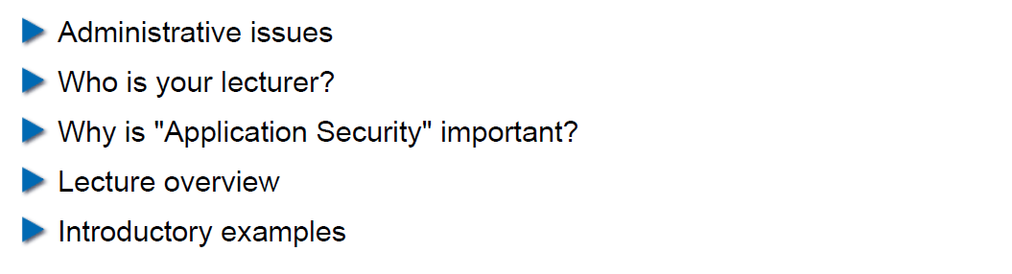

## Administrative Issues

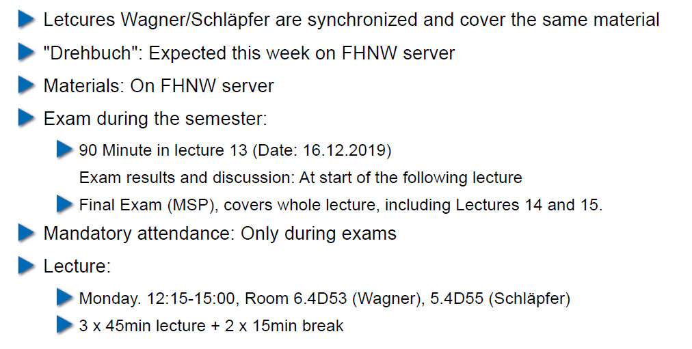

## Who is Your Lecturer (Wagner)

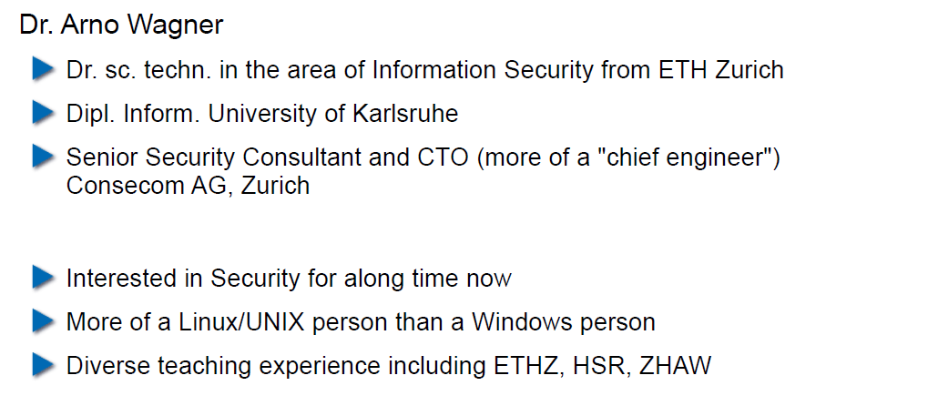

## whoami (Schläpfer)

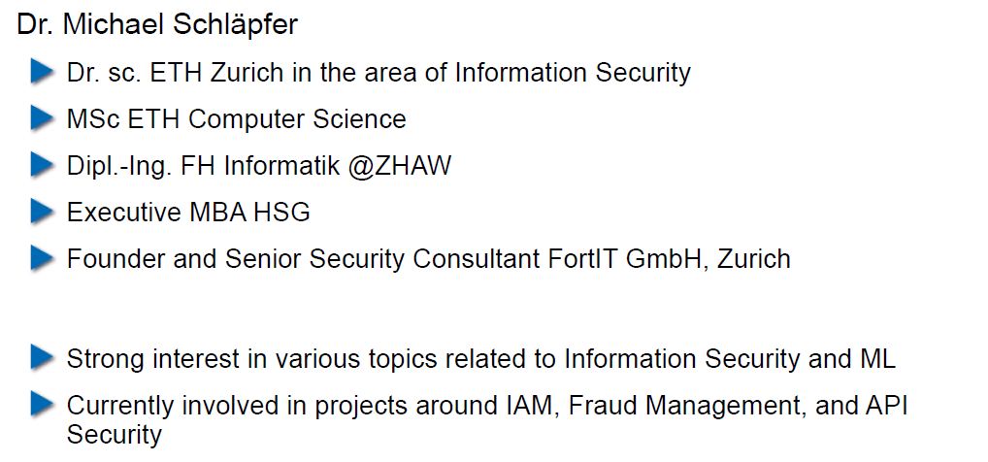

## Why is Application Security Important?

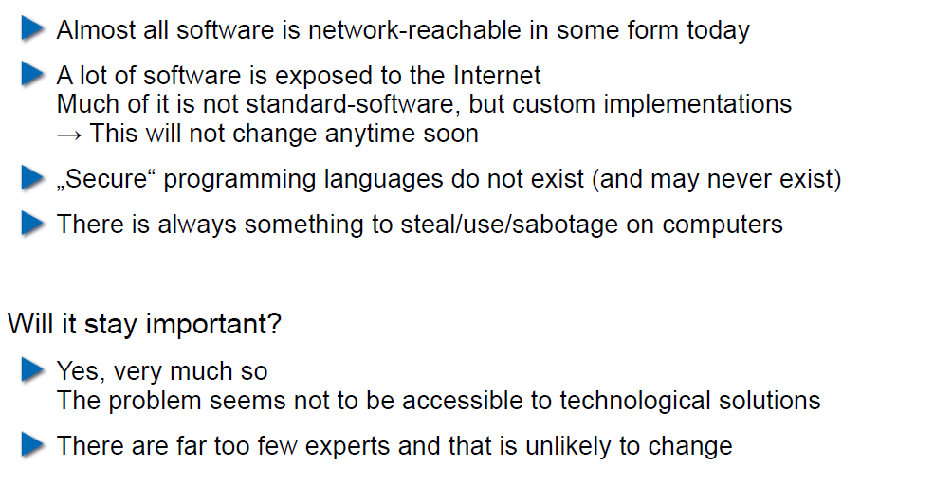

## Lecture Overview (1)

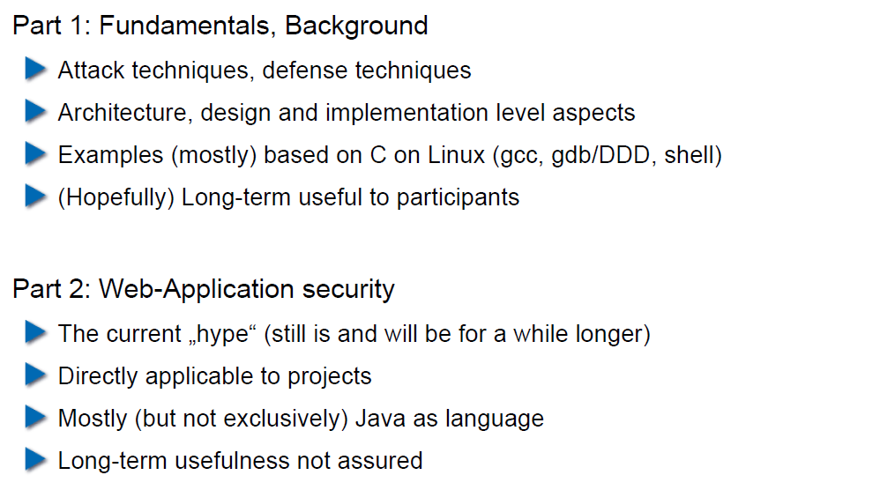

## Lecture Overview (2)

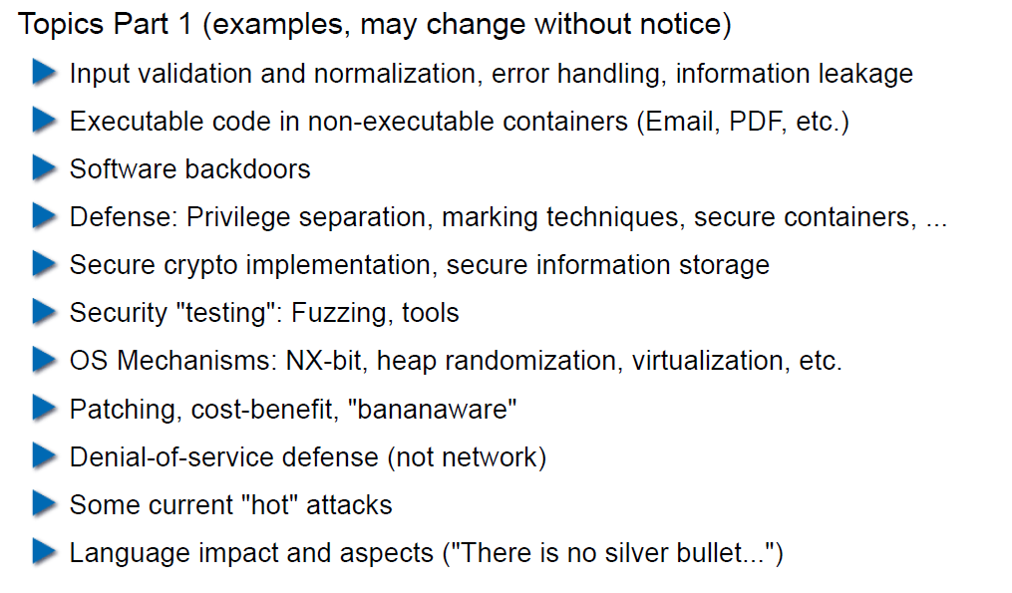

## Lecture Overview (3)

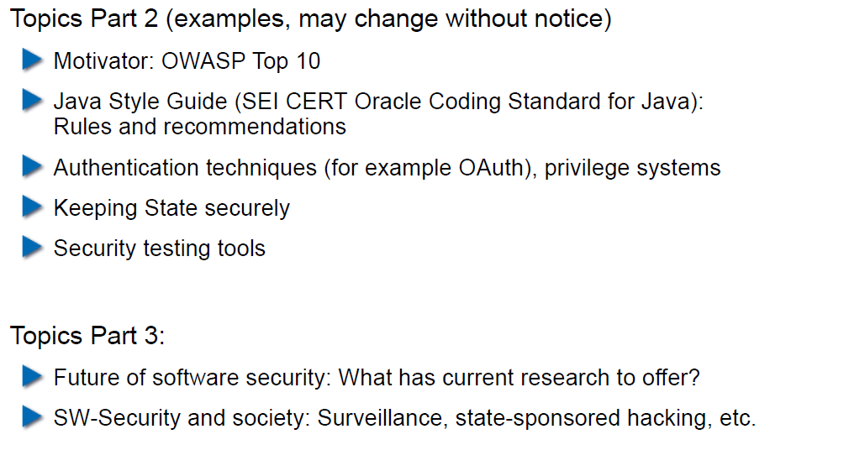

## Example: Buffer Overflow

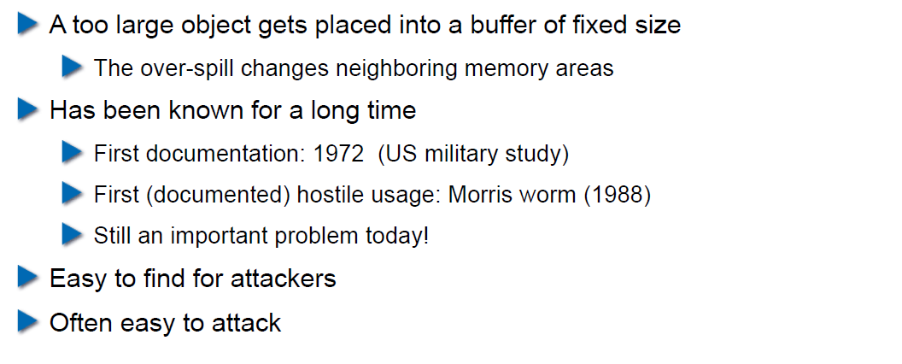

## How does a Buffer Overflow Work?

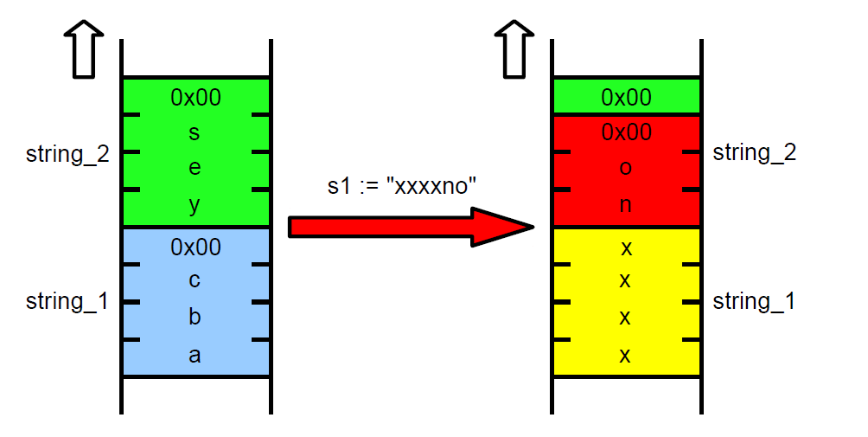

## Buffer Overflow Demo

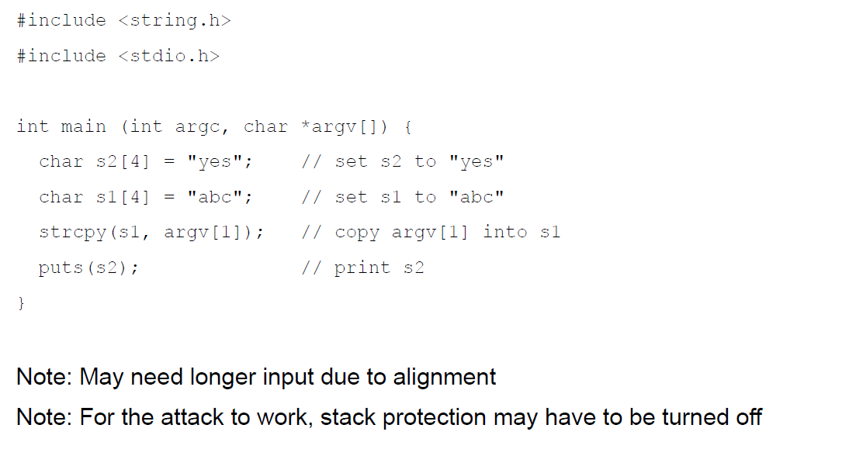

## Not Really a Fix for Buffer Overflow: Stack Protection

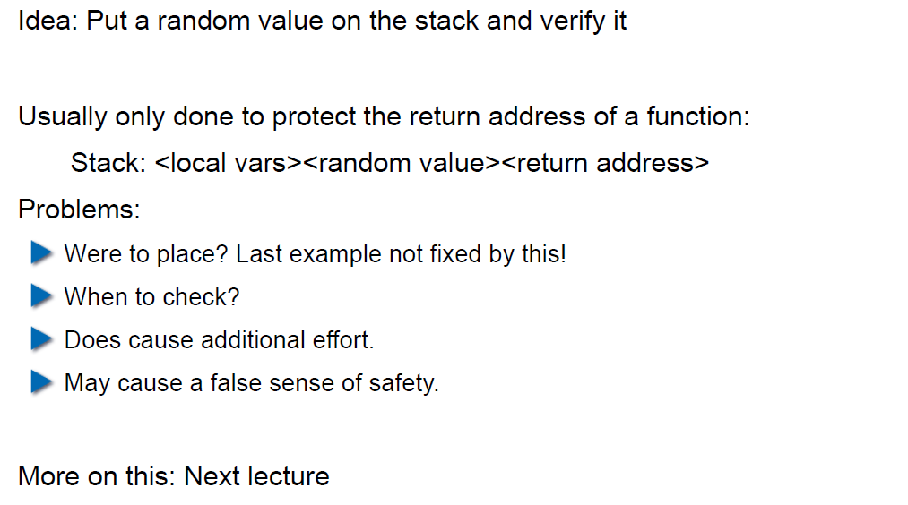

## Fix for Buffer Overflow: Checked Buffers

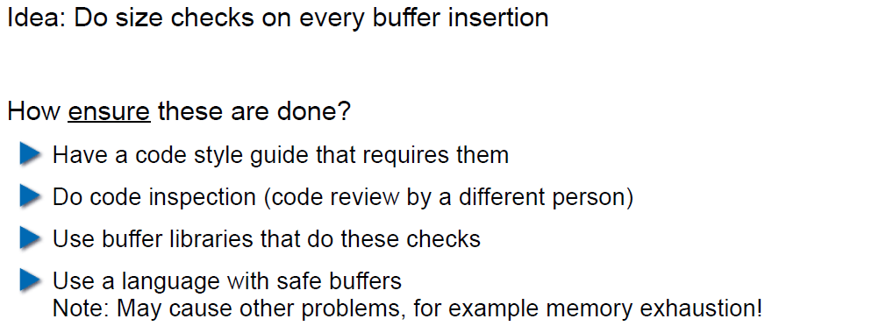

## Example: Taint Checking in Perl (1)

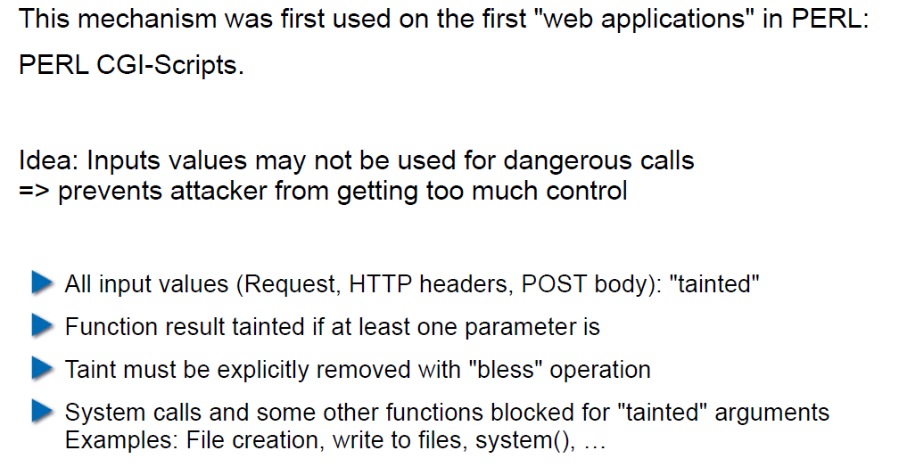

## Example: Taint Checking (2)

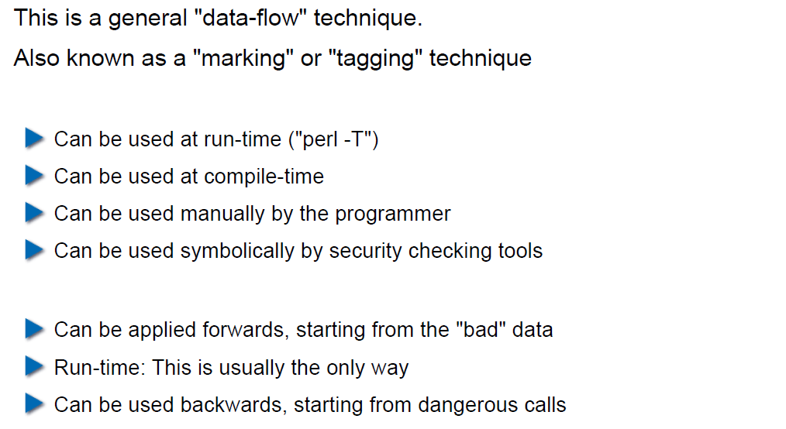

## Example: Taint Checking (3)

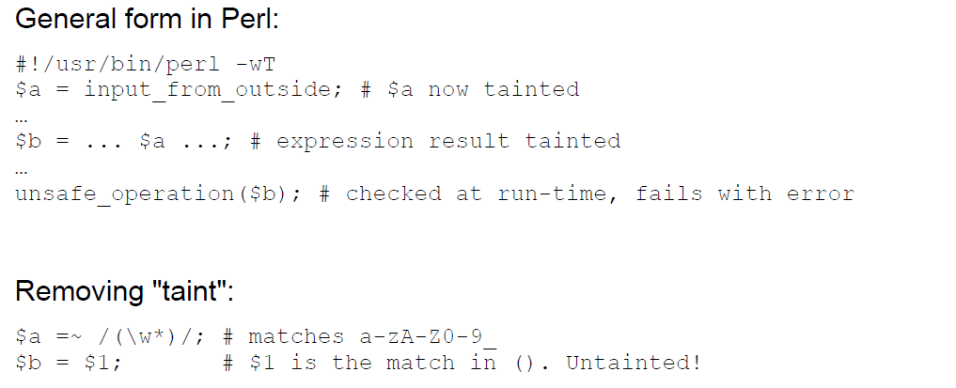

## Example: Taint Checking (4)

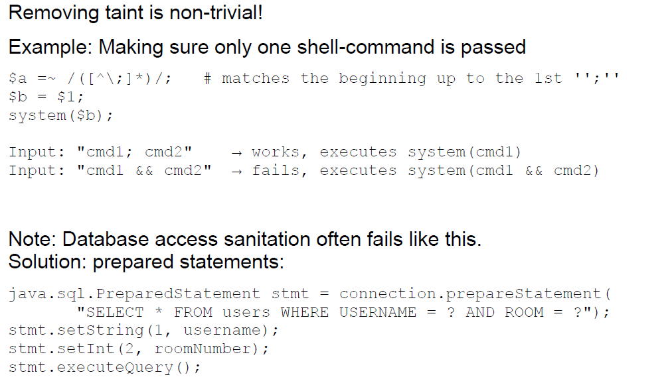

## Example: Data Leakage by Behavior (1)

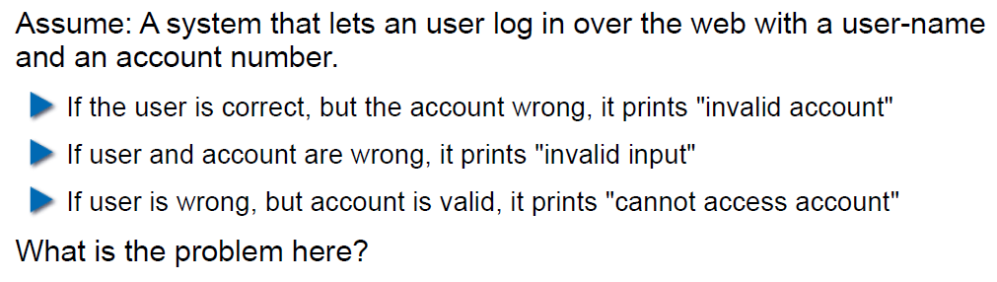

## Example: Data Leakage by Behavior (2)

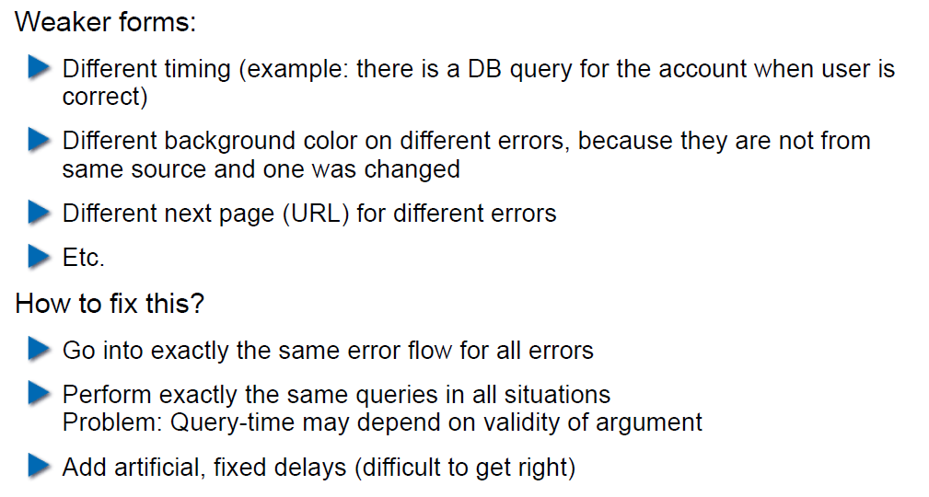

## Example: Data Leakage by Error Output

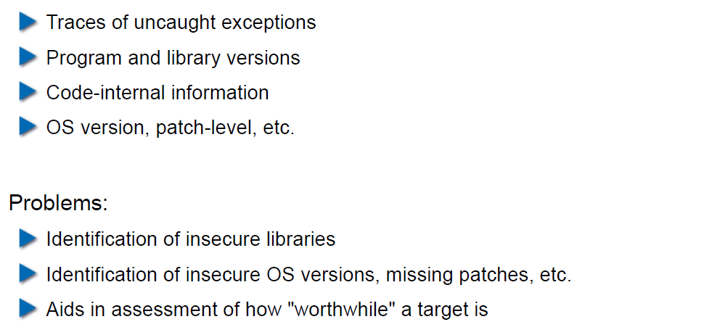

## Human Factors

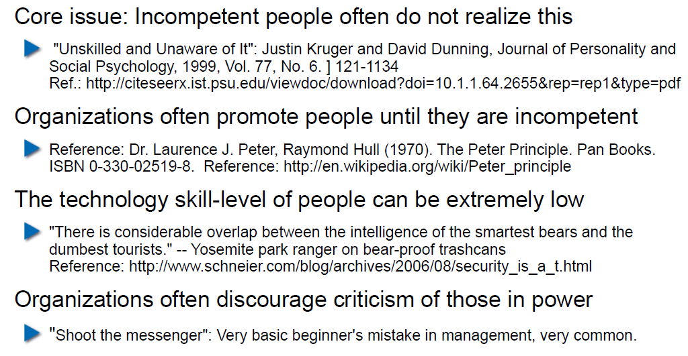

## Exercises and Preparation for Next Week

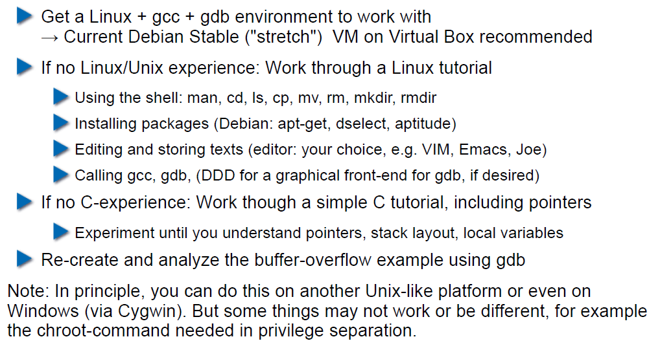

## Reserve

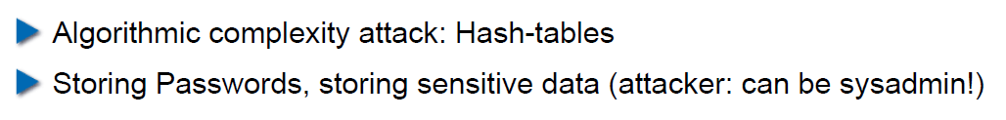

# Woche 2

## Agenda

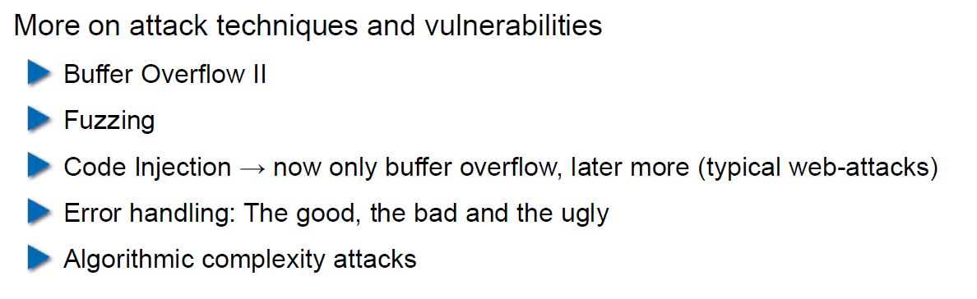

## Recap: What do Attackers Want?

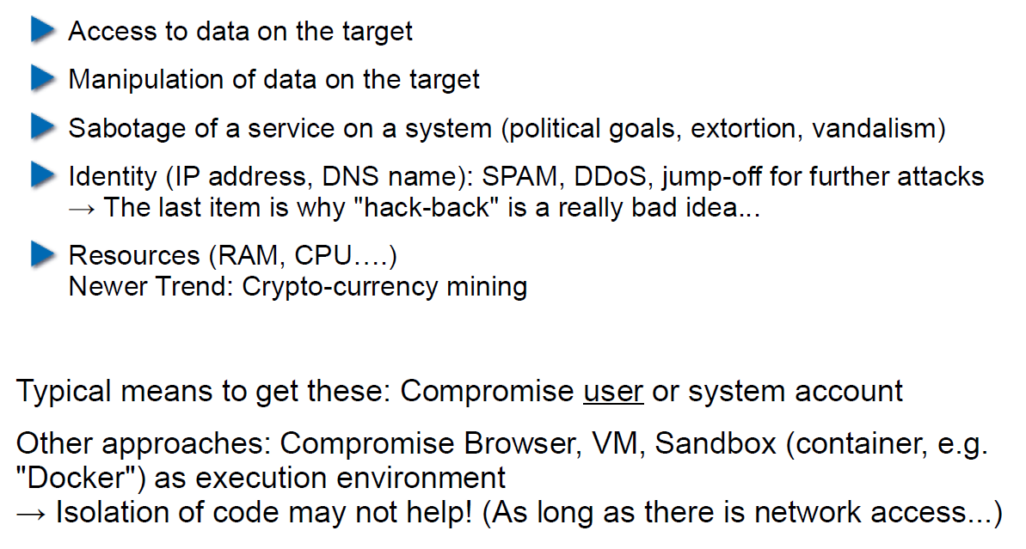

## Buffer Overflow II

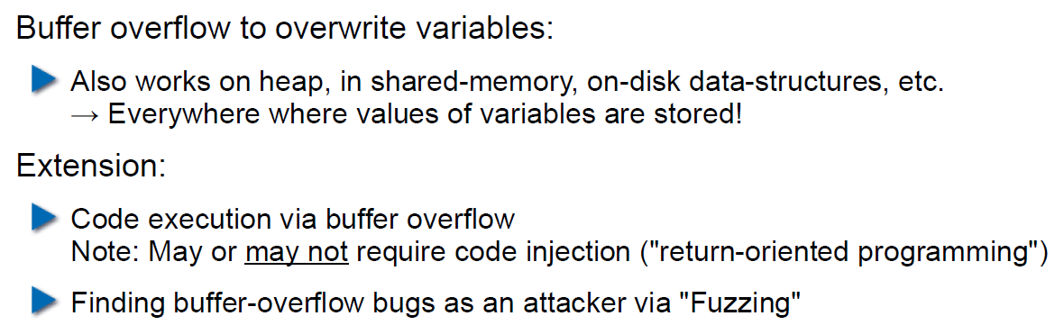

## Buffer Overflow II

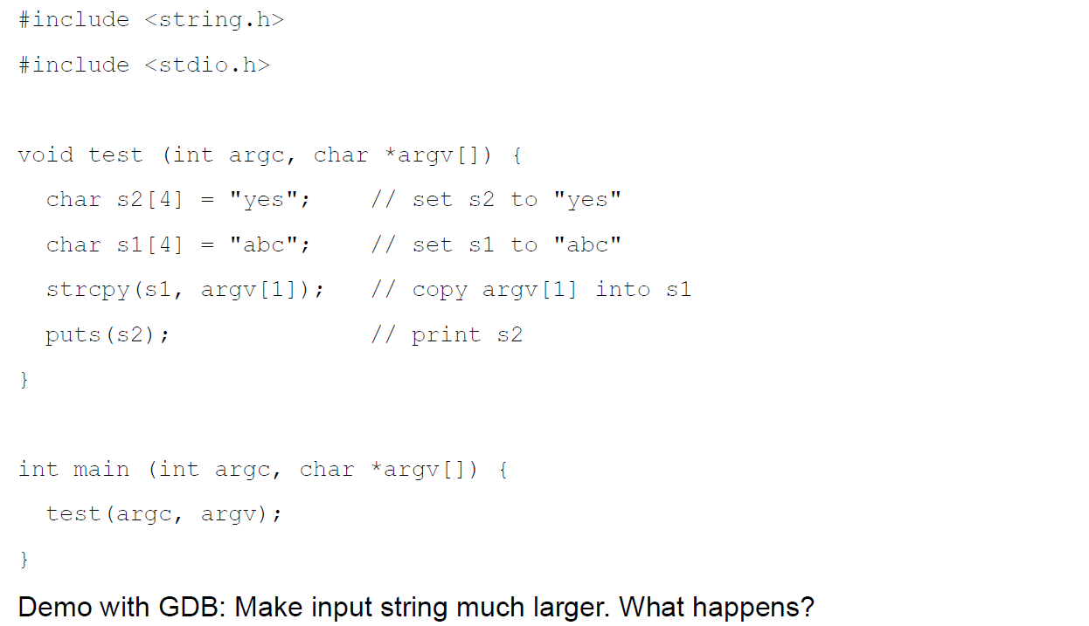

## Buffer Overflow II

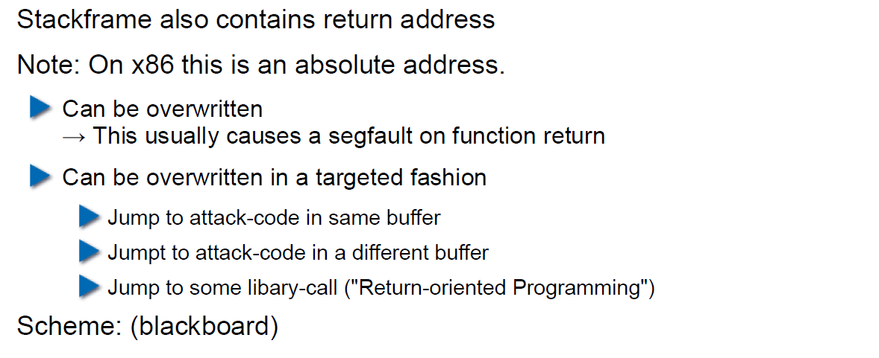

## Buffer Overflow II

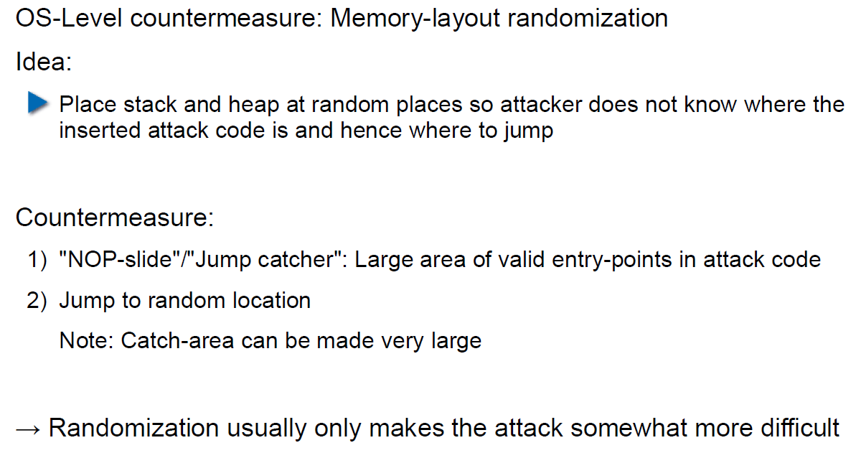

## Buffer Overflow II

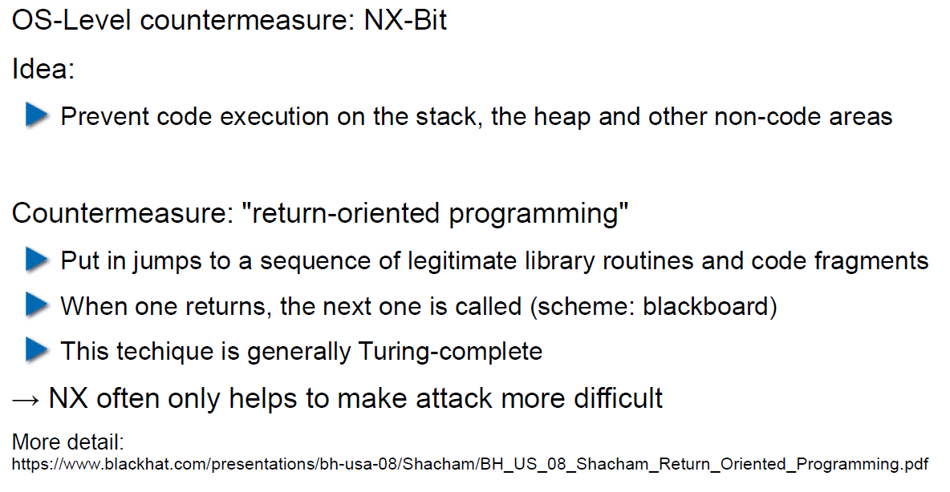

## Attack Technique: Fuzzing

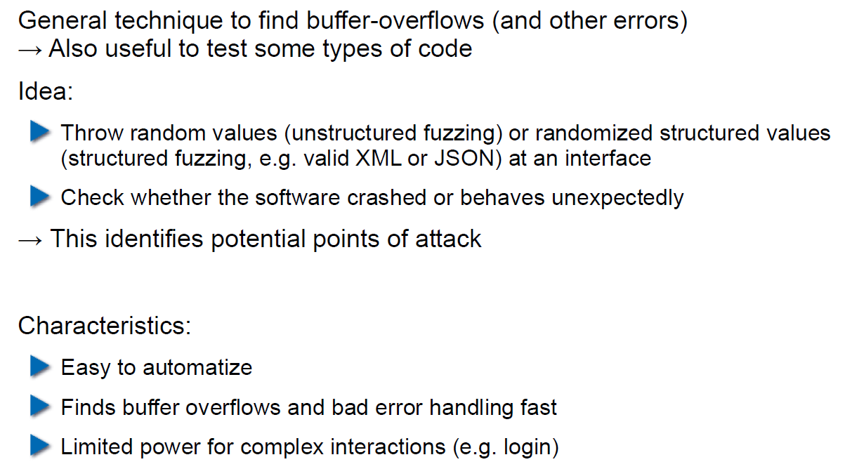

## Error Handling

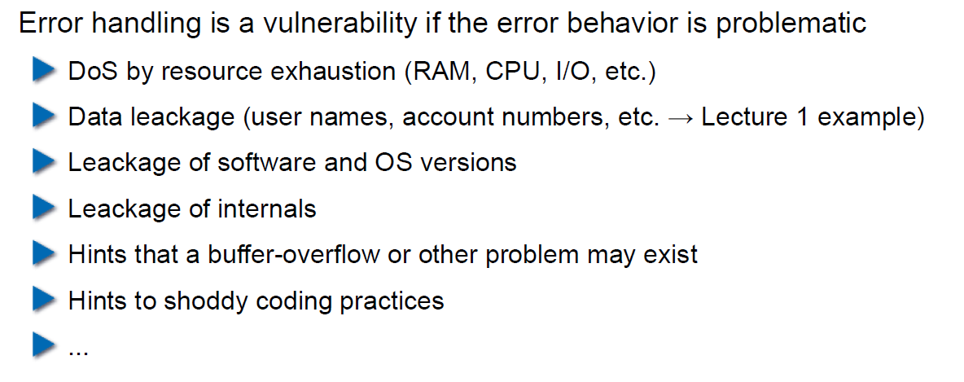

## Case study – Handling too long input

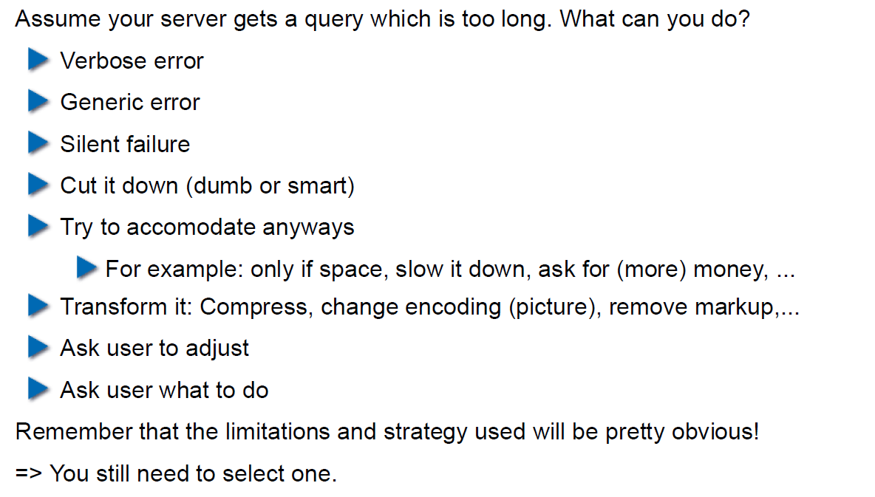

## Case-study: Compression Bomb

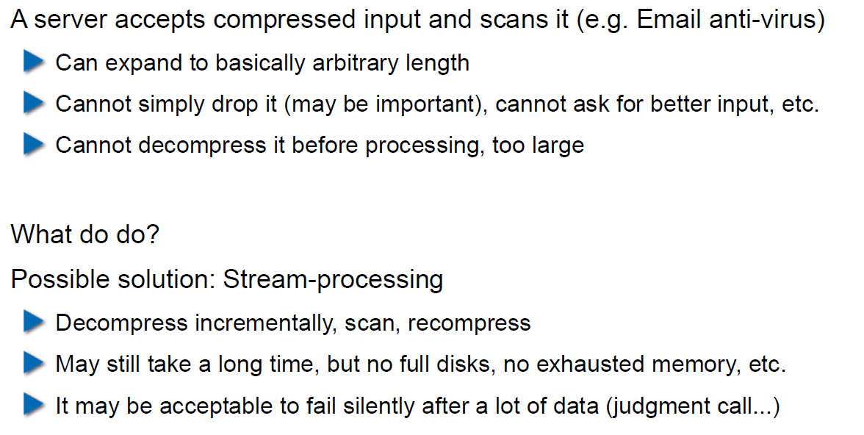

## Error Handling

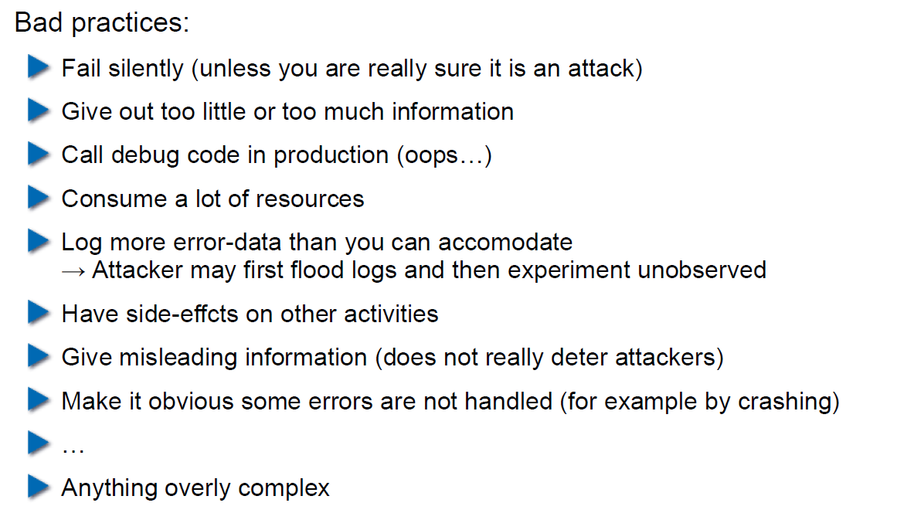

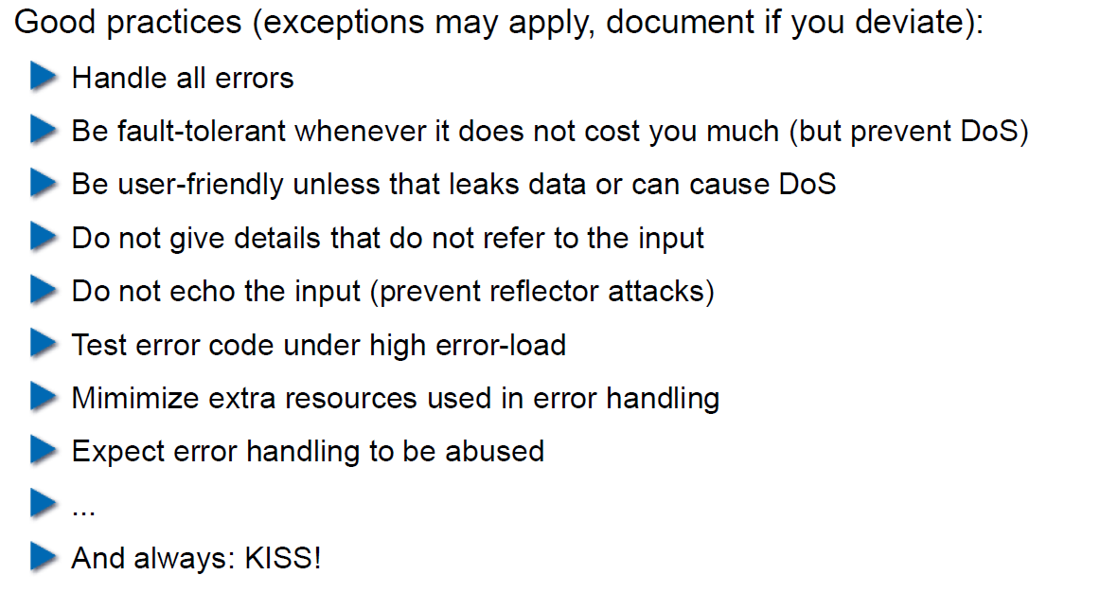

## Algorithmic Complexity Attacks

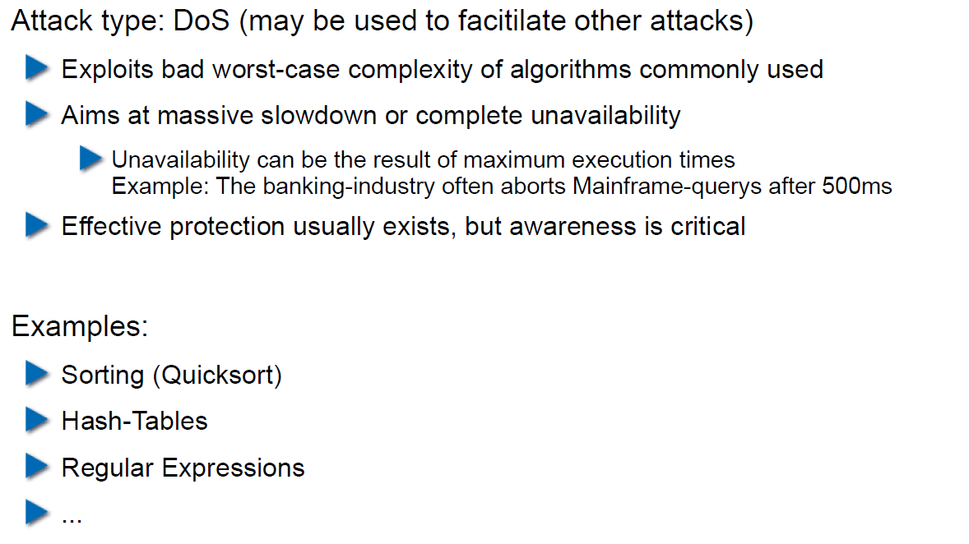

## Algorithmic Complexity: Sorting

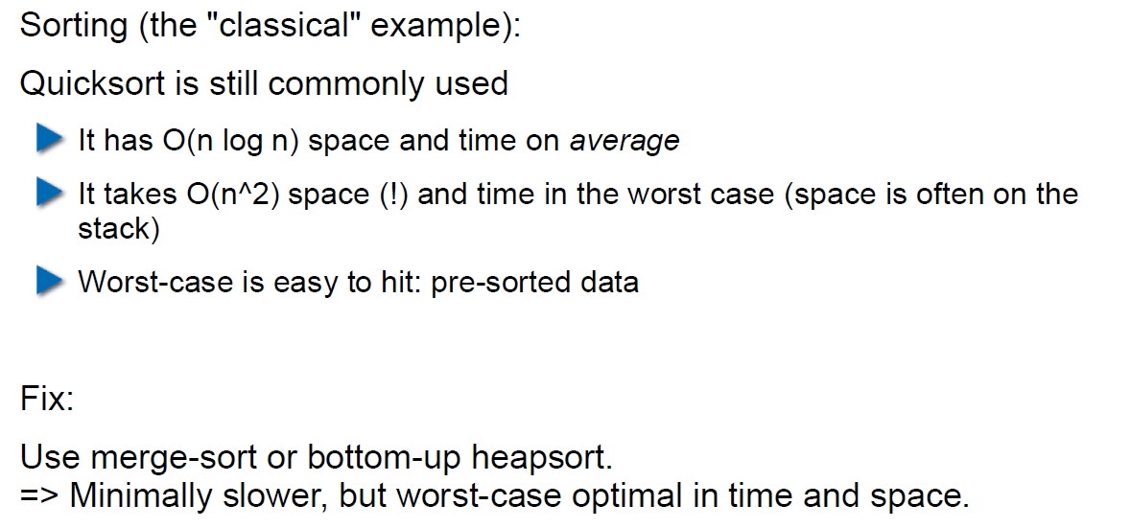

## Algorithmic Complexity: Hashing

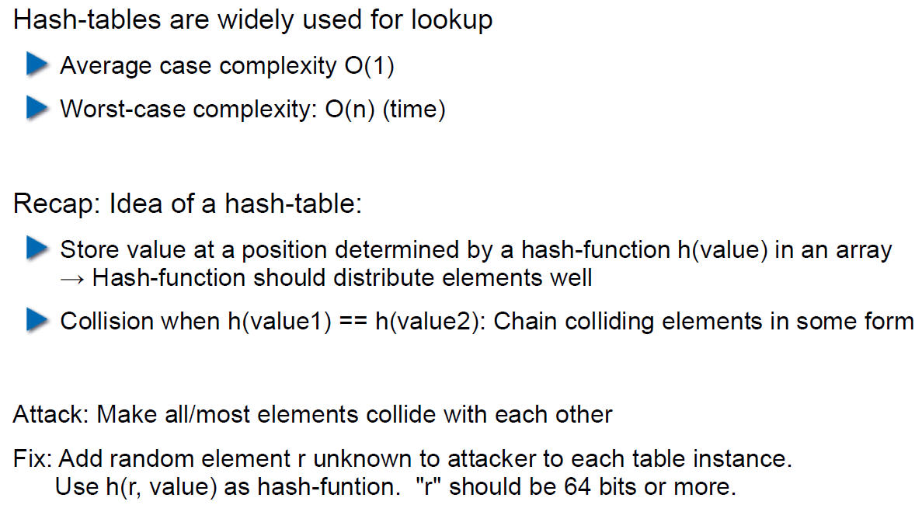

## Algorithmic Complexity: Regular Expressions

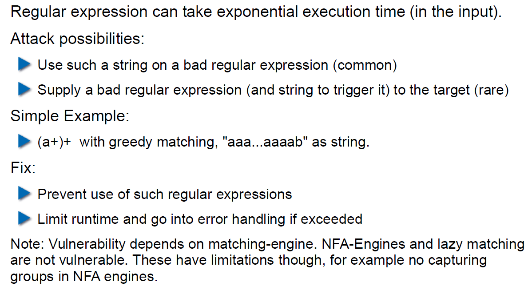

# Woche 3

## Agenda

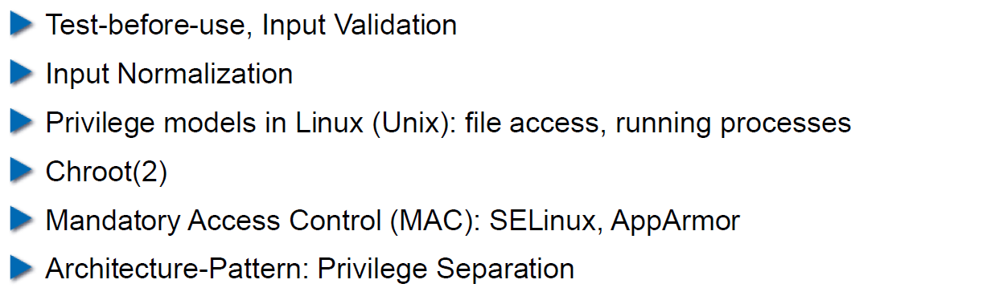

## Secure Coding Principle: Test-before-use

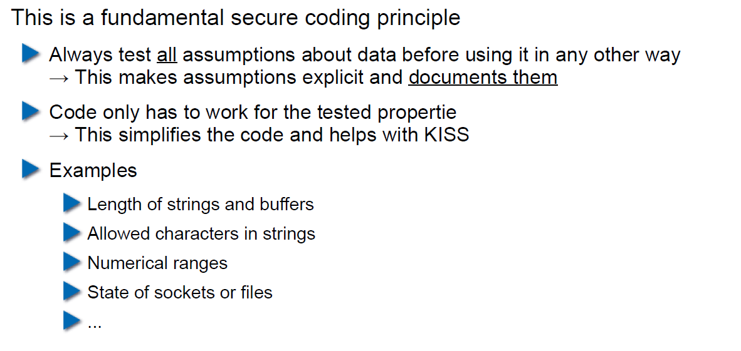

## Input Validation

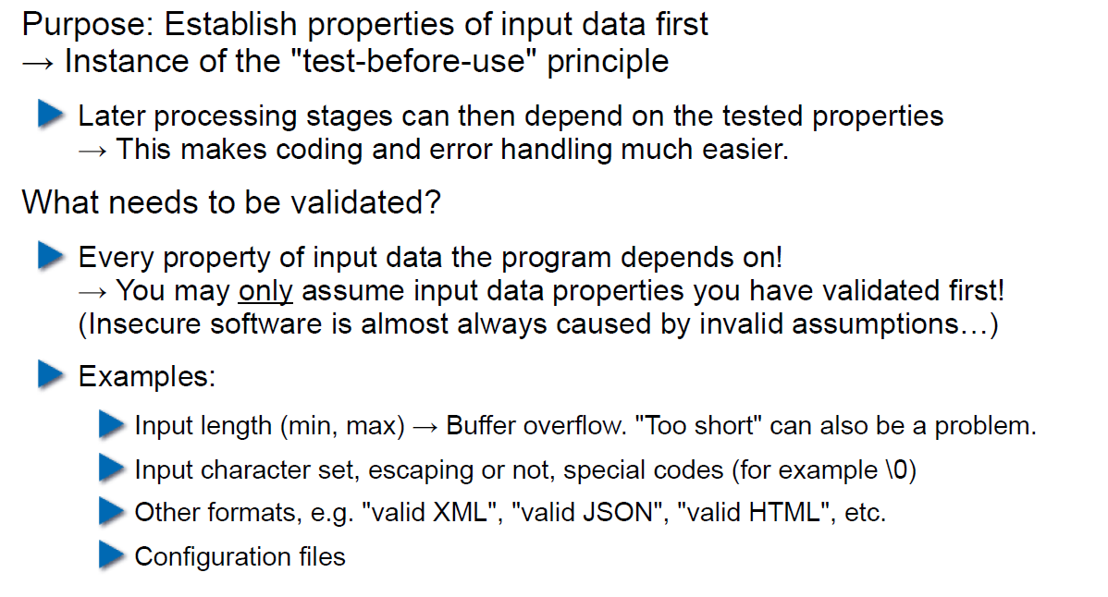

## Input Normalization

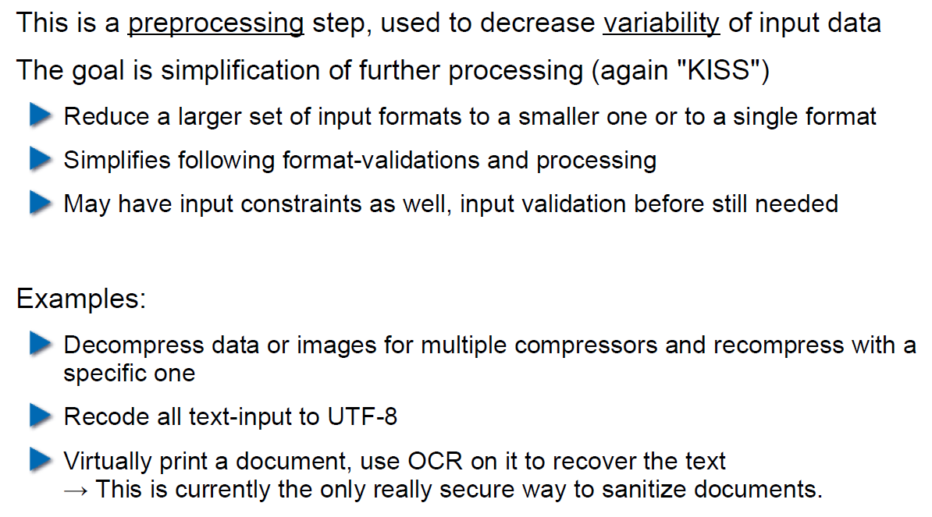

## Unix Permission Model (simplified)

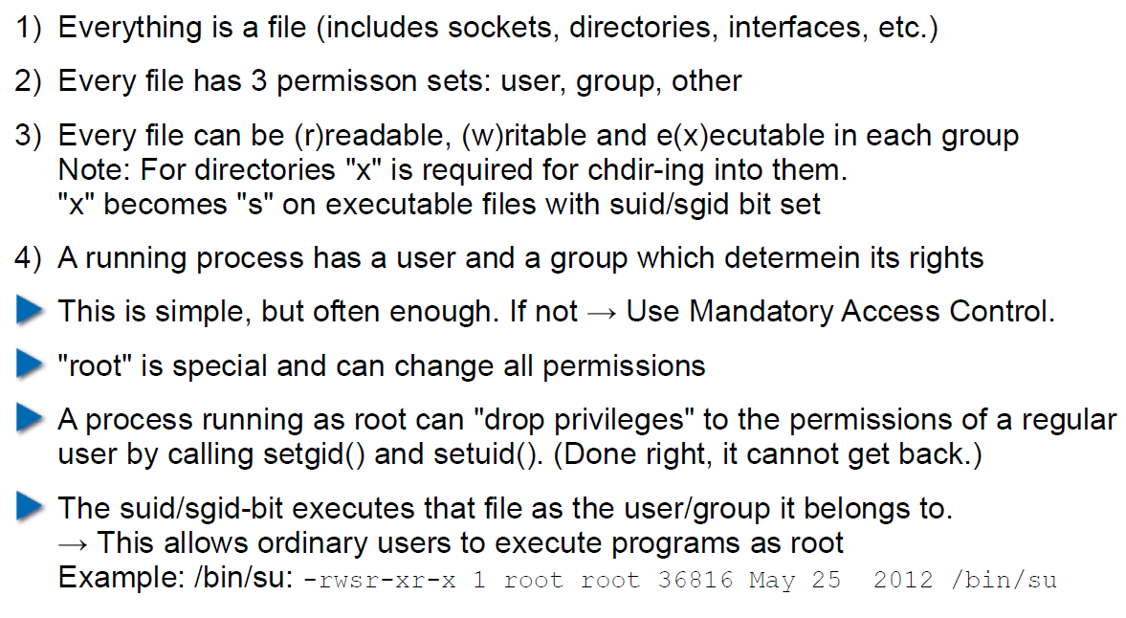

## Chroot

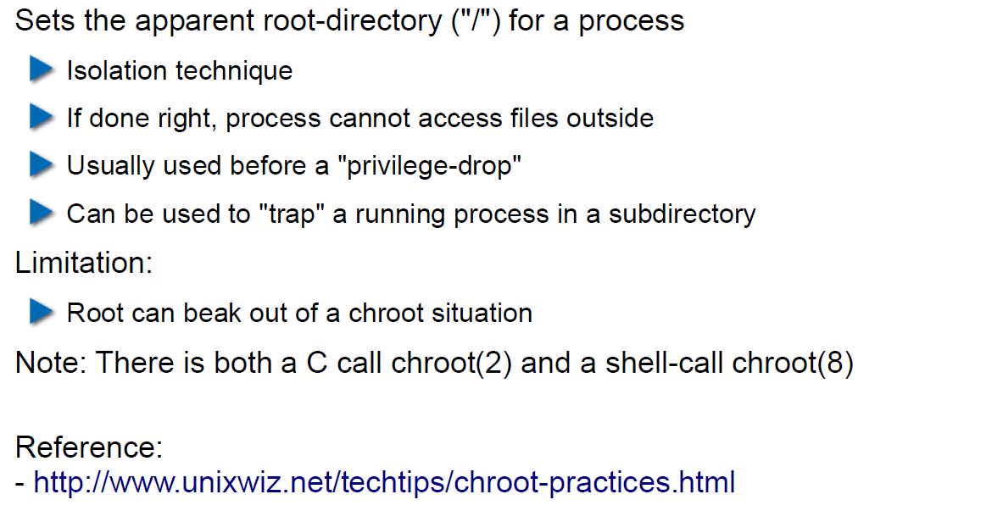

## Mandatory Access Control (MAC)

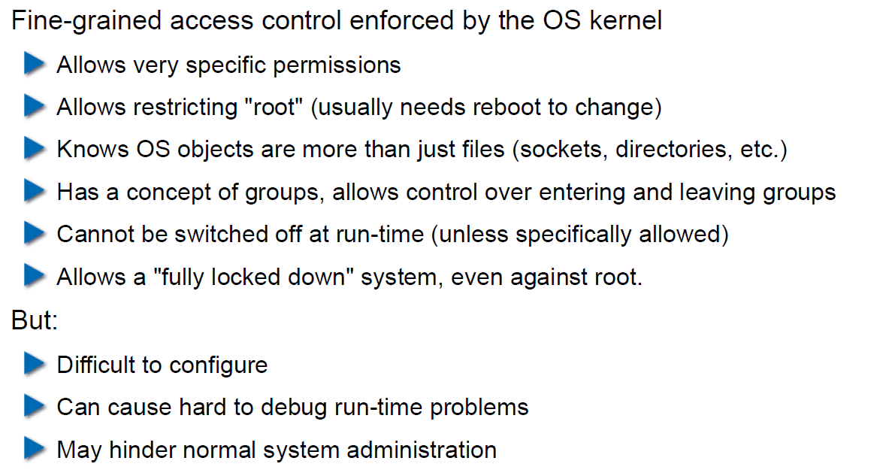

## MAC Example: SELinux

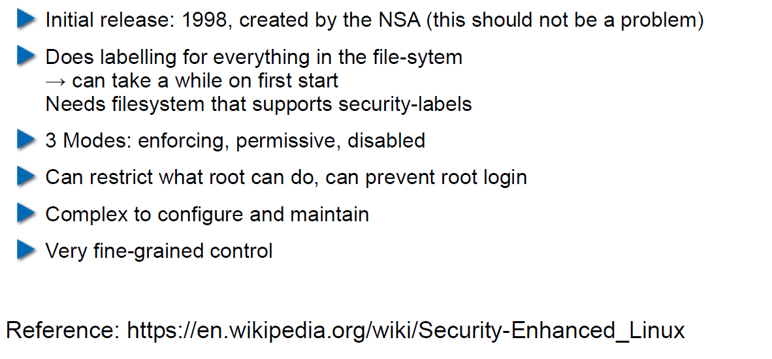

## MAC Example: AppArmor

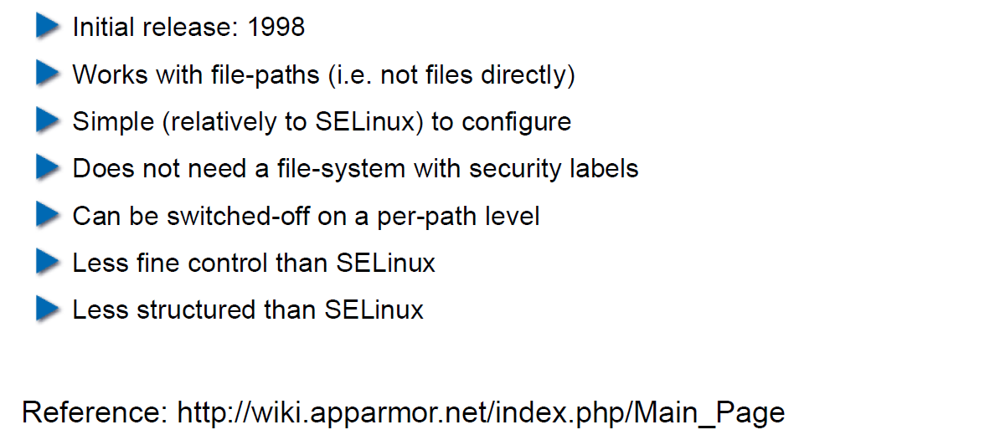

## Secure Coding Principle: Defense in Depth

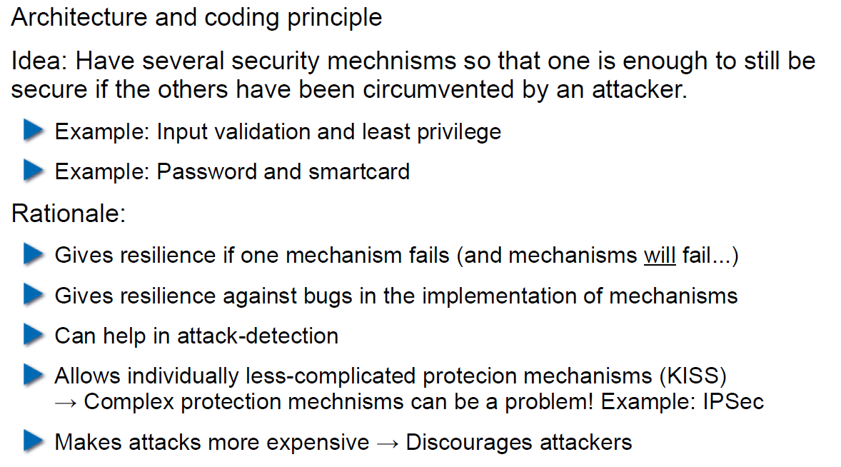

## Privilege Separation

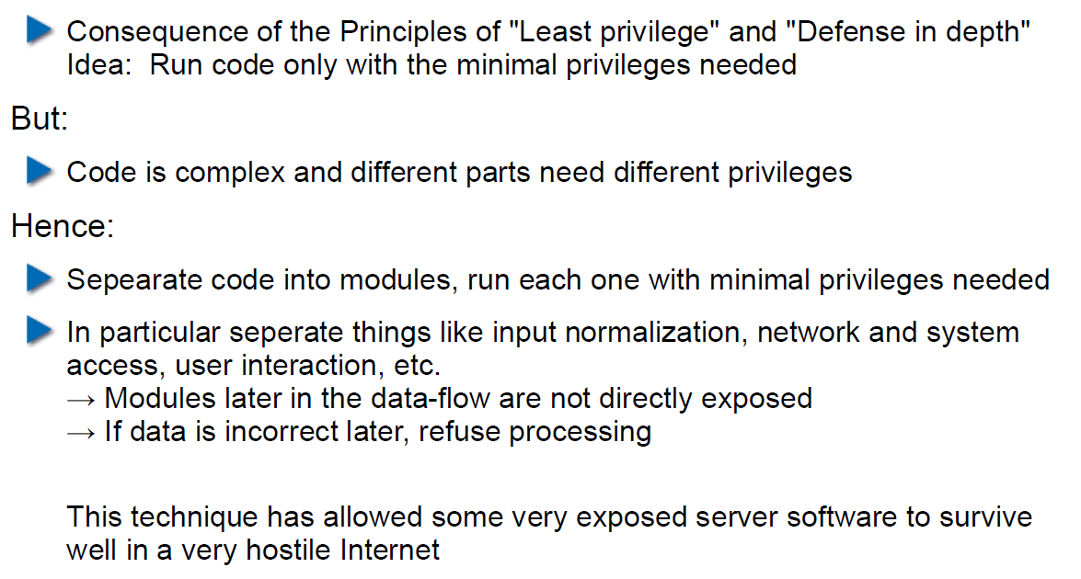

## Overall Idea

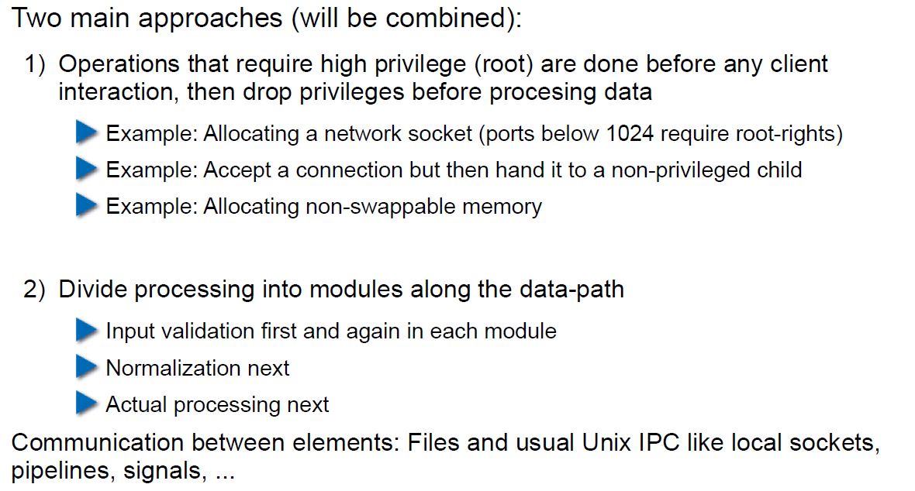

## Form of the Modules

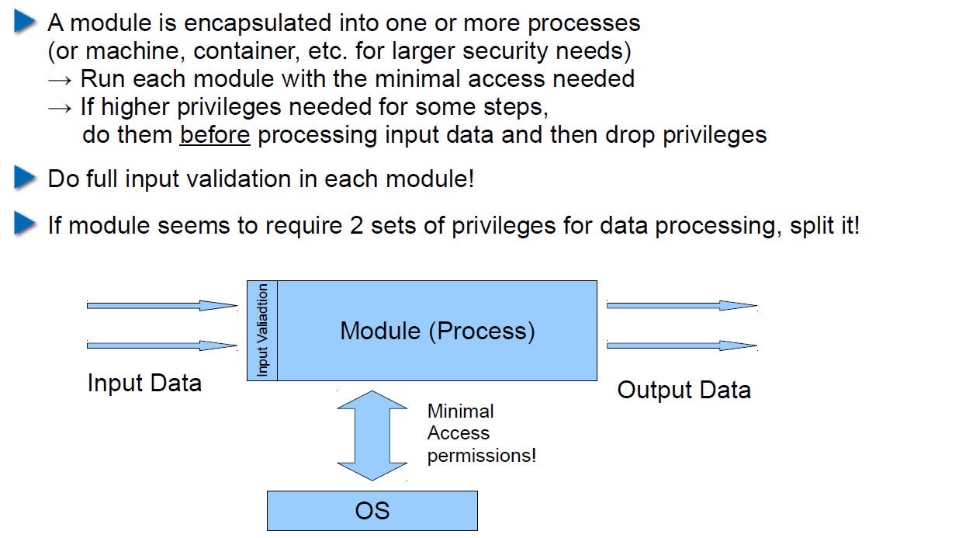

## Example: OpenSSH

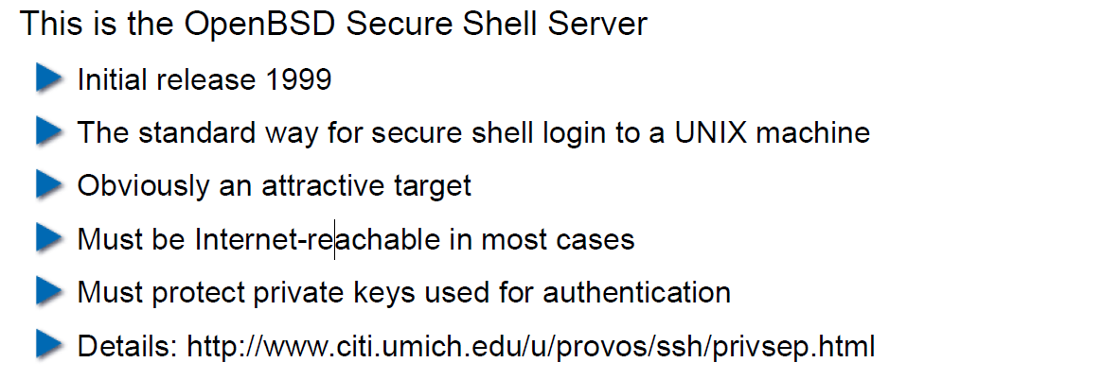

## OpenSSH: Privilege Separation Approach

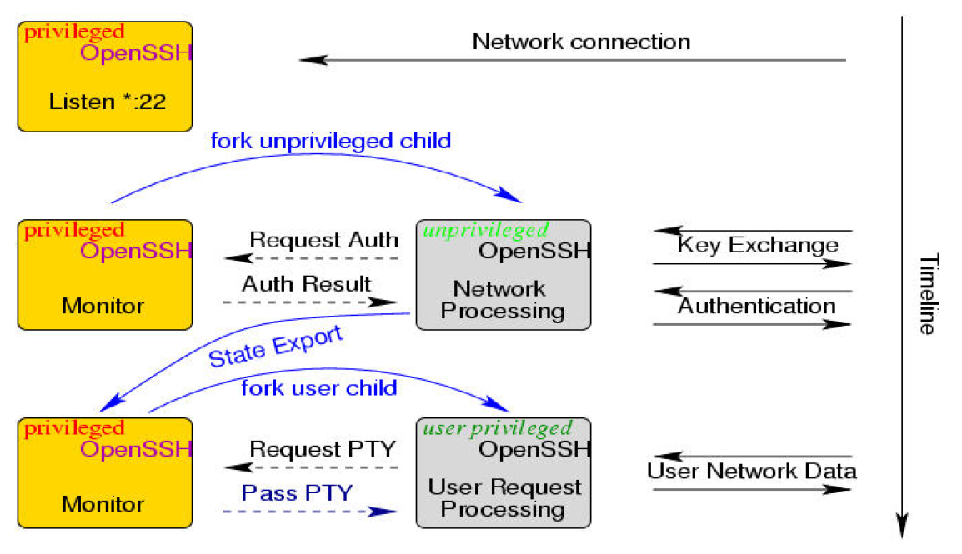

## Example: Postfix MTA (Email Server)

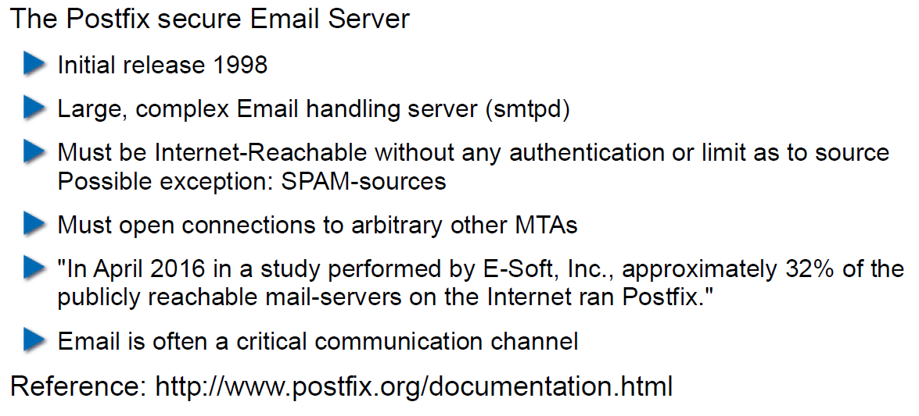

## Postfix System View

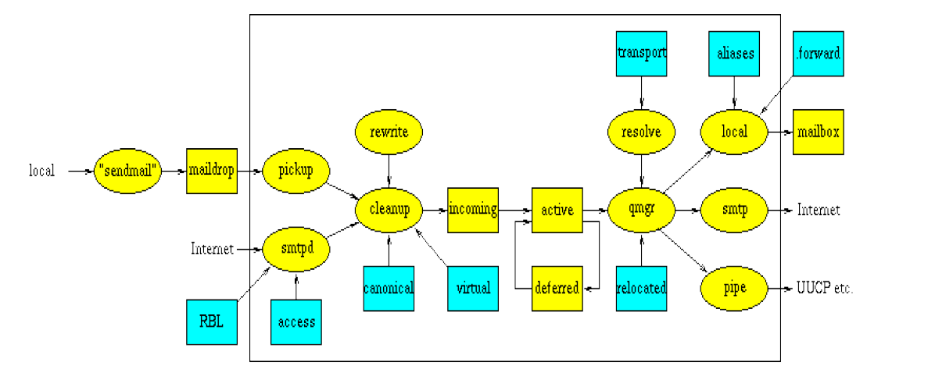

## Postfix: Example Data-Flow

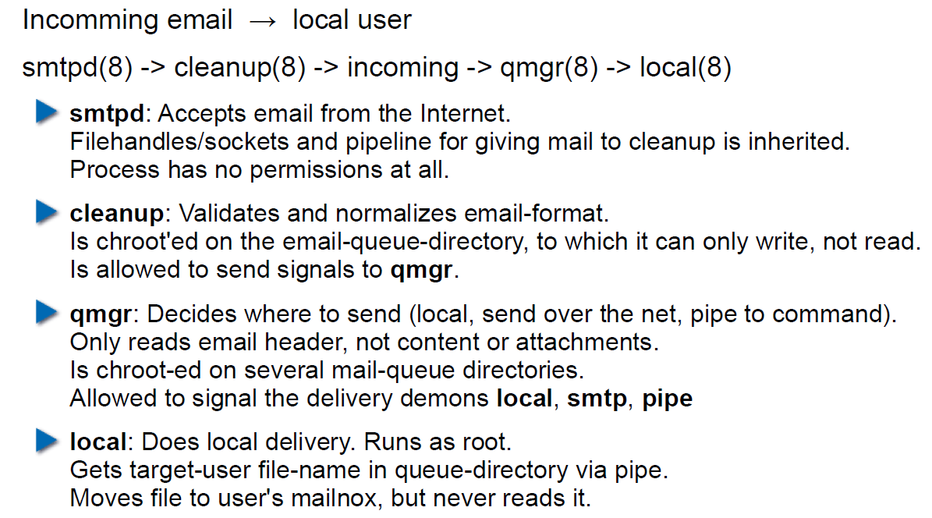

# Woche 4

## Agenda

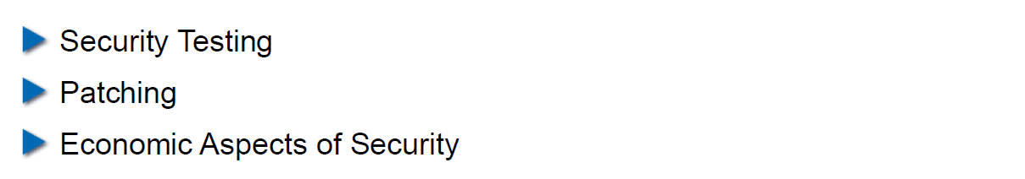

## Security Testing (for Software)

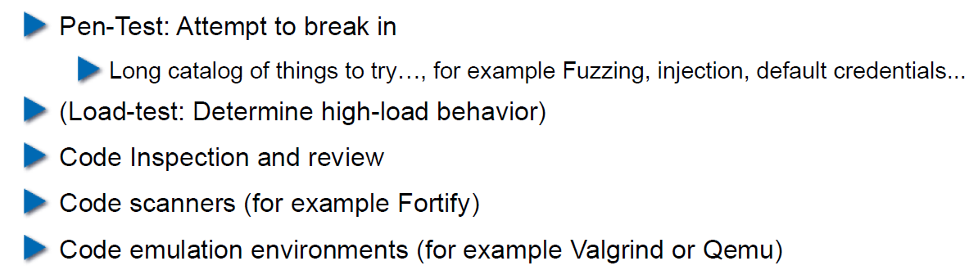

## Pen-Test

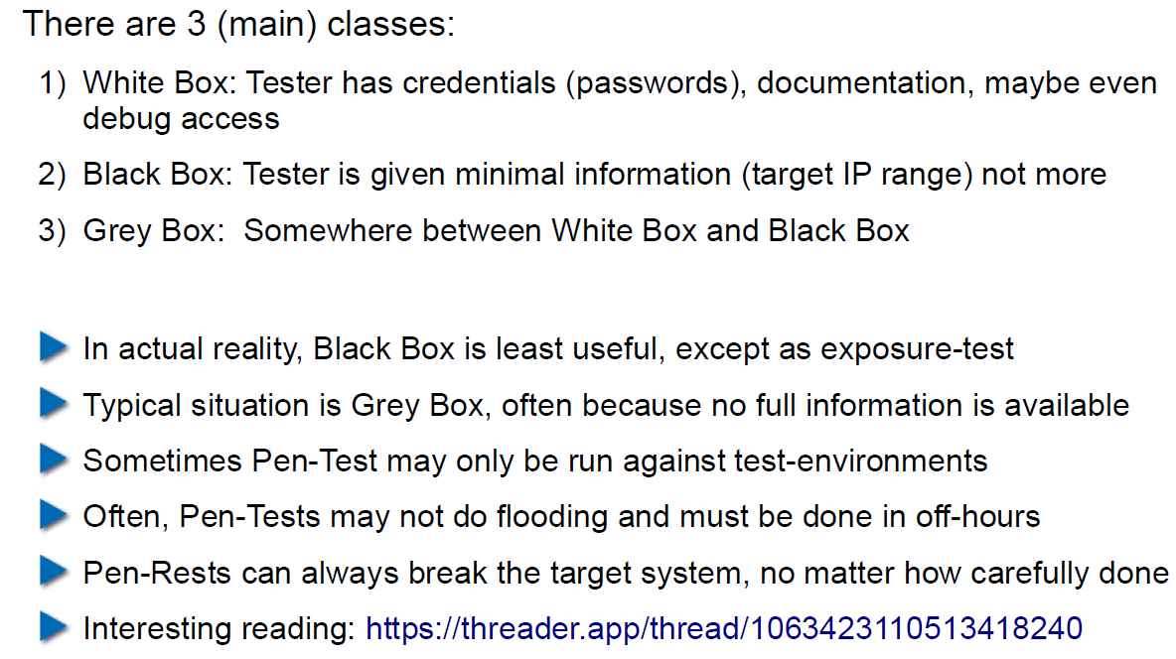

## How does a Pen-Test fail?

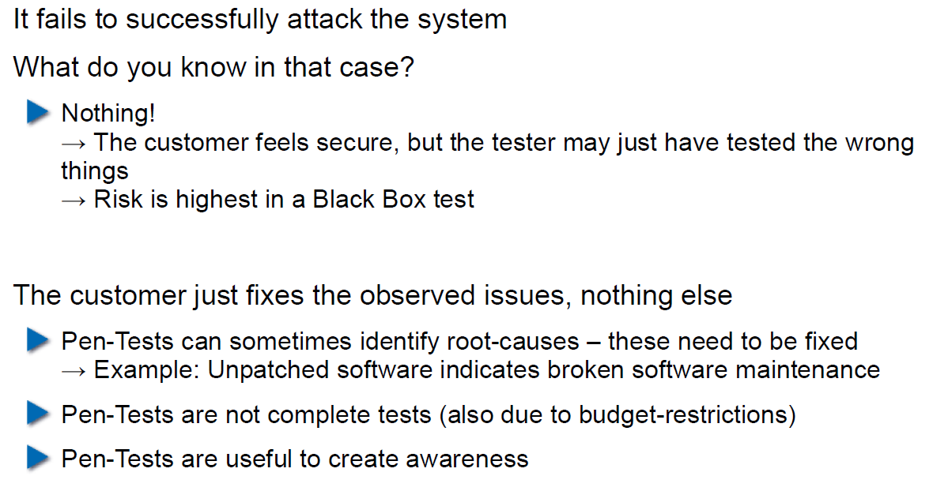

## Code Inspection and Review

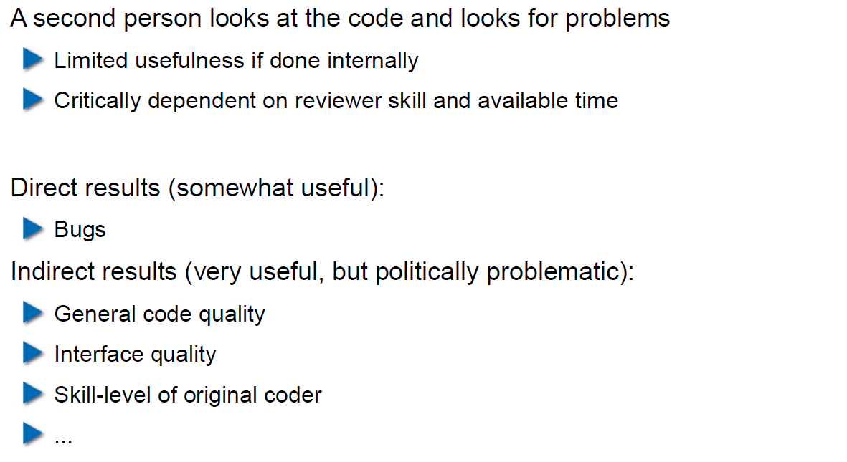

## Code Scanners

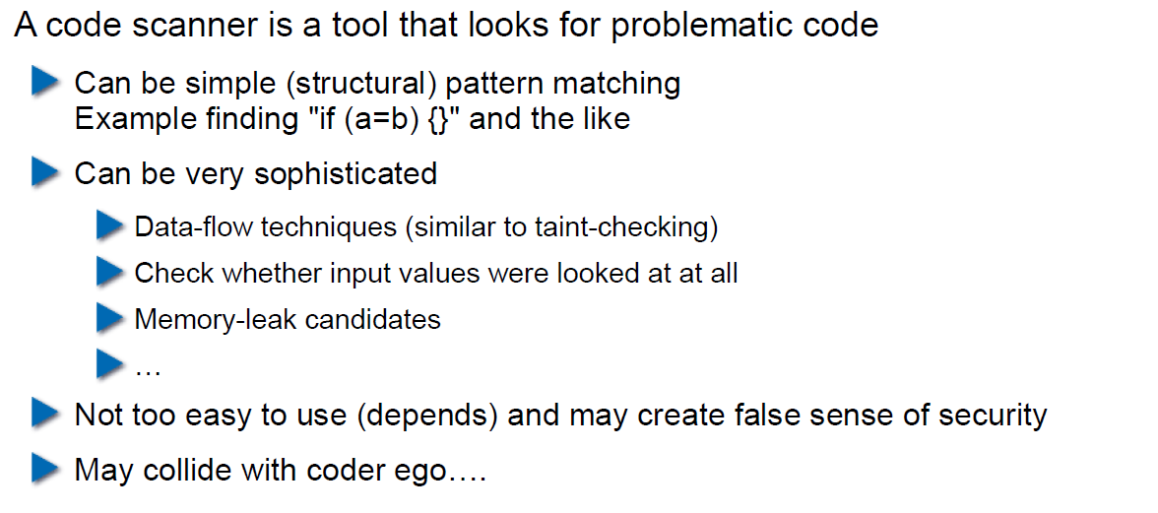

## Execution Emulators

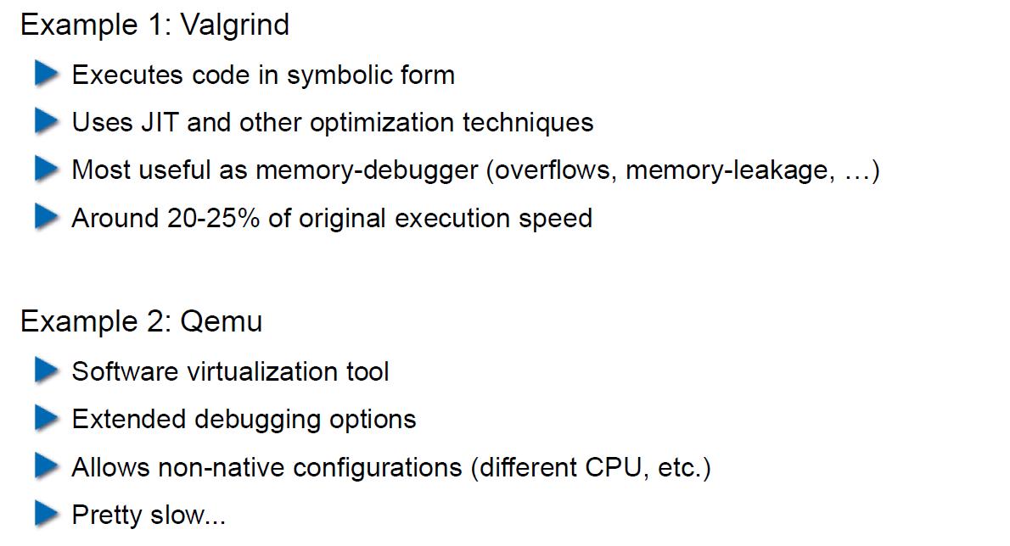

## Patching

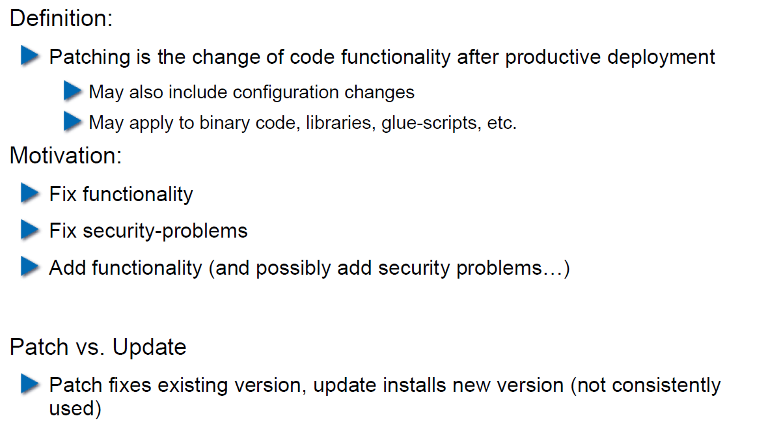

## How to Patch

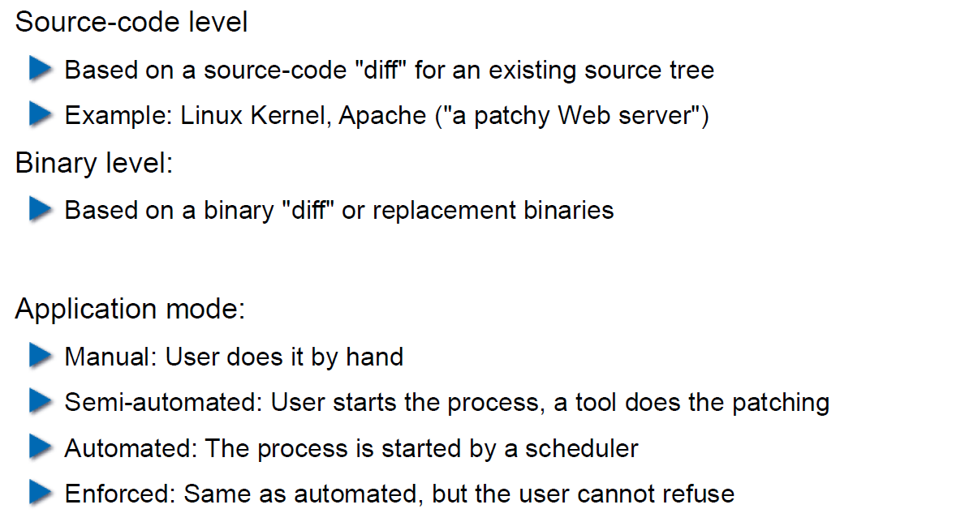

## Problems with Patching

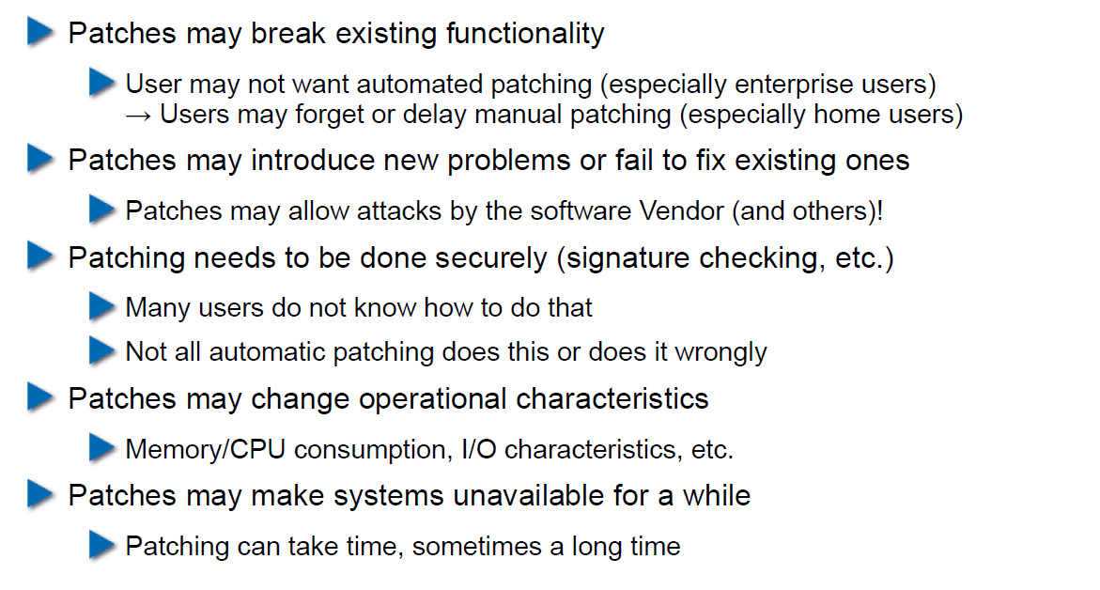

## Problems with not Patching

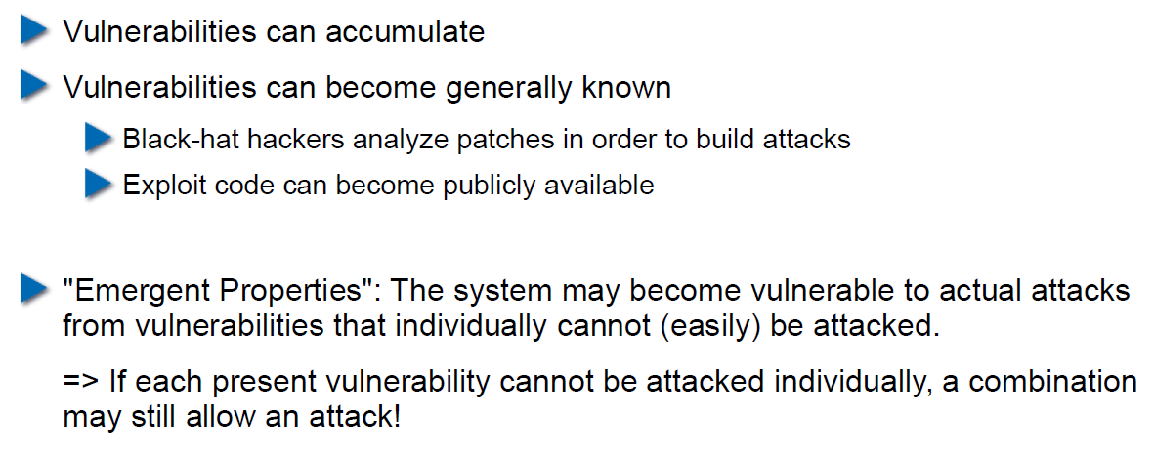

## Problems with Unavailability of Patches

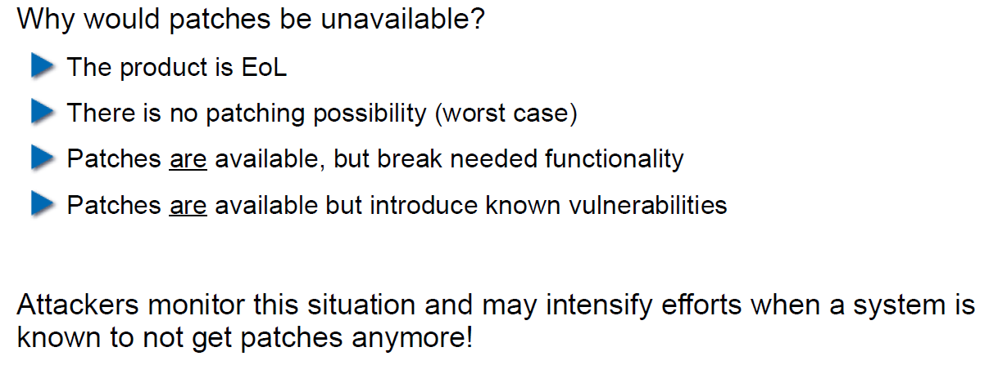

## Economic Aspects of Security

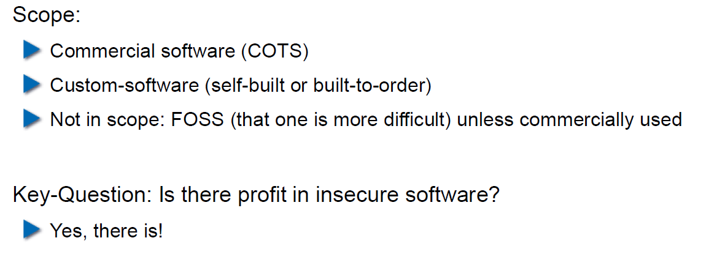

## Case Study: DDoS on Brian Krebs (20.9.2016)

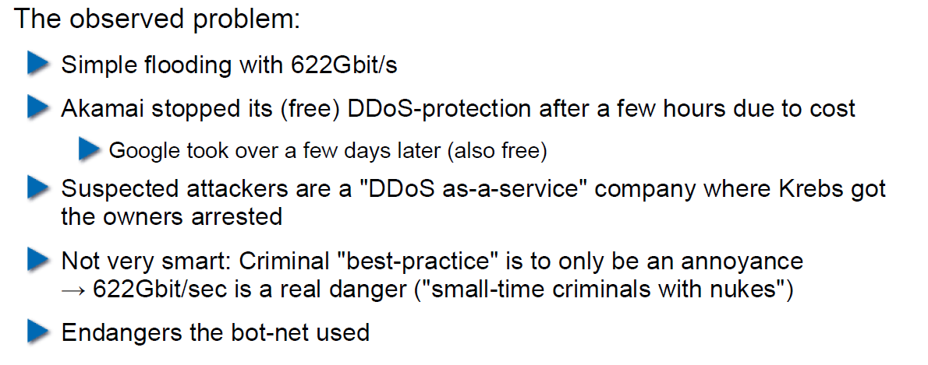

## What can Perform Such an Attack?

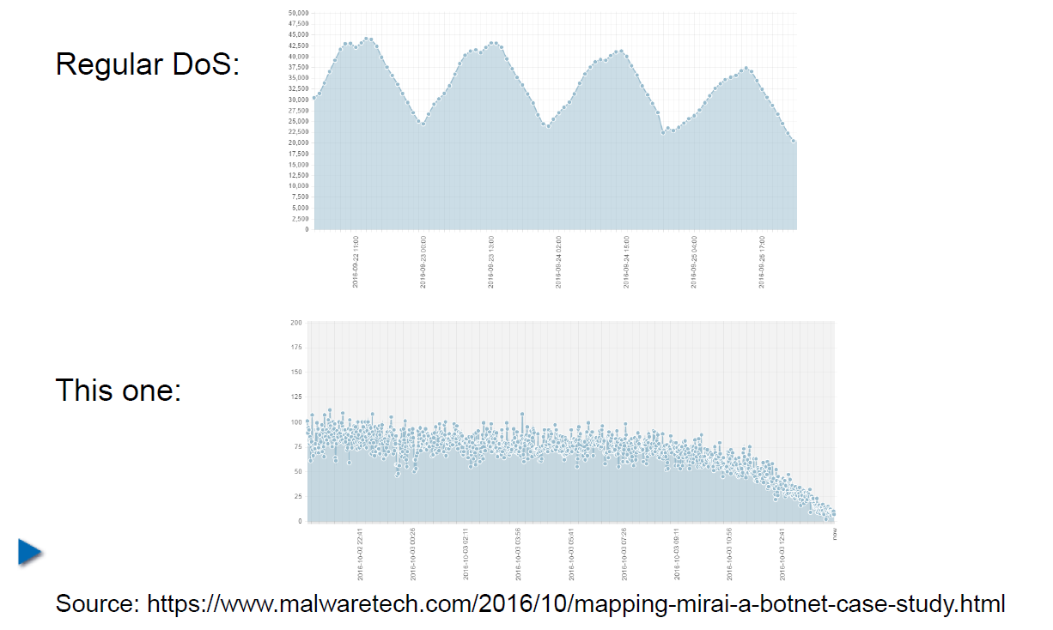

## IoT: Internet of insecure Things

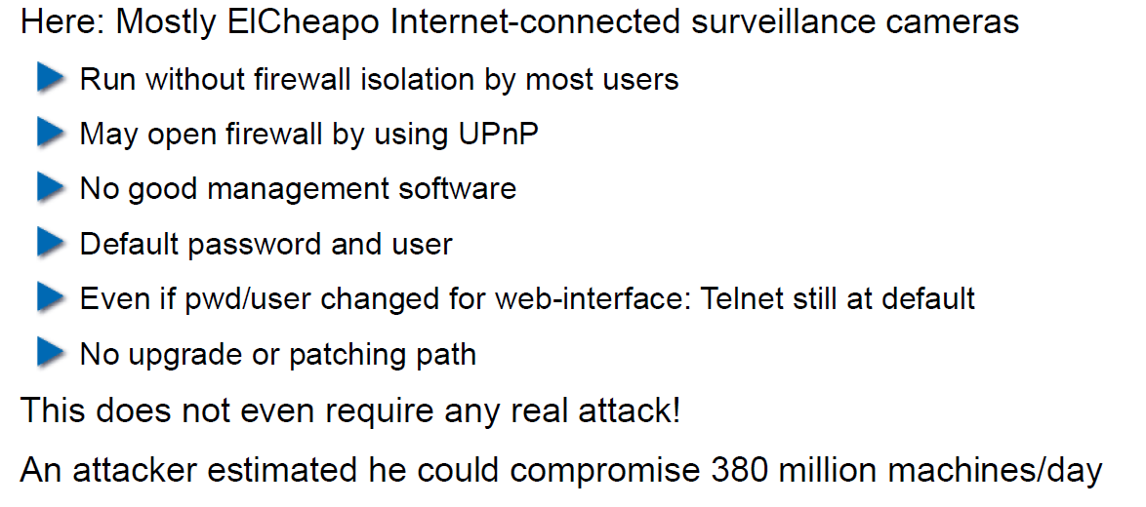

## Why are These IoT Devices so Insecure?

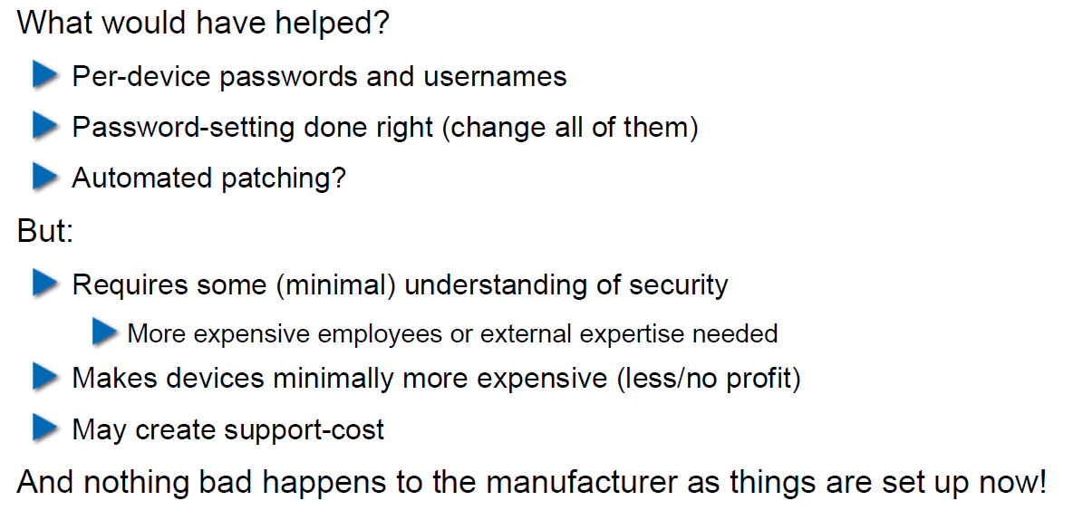

## Possible Solutions

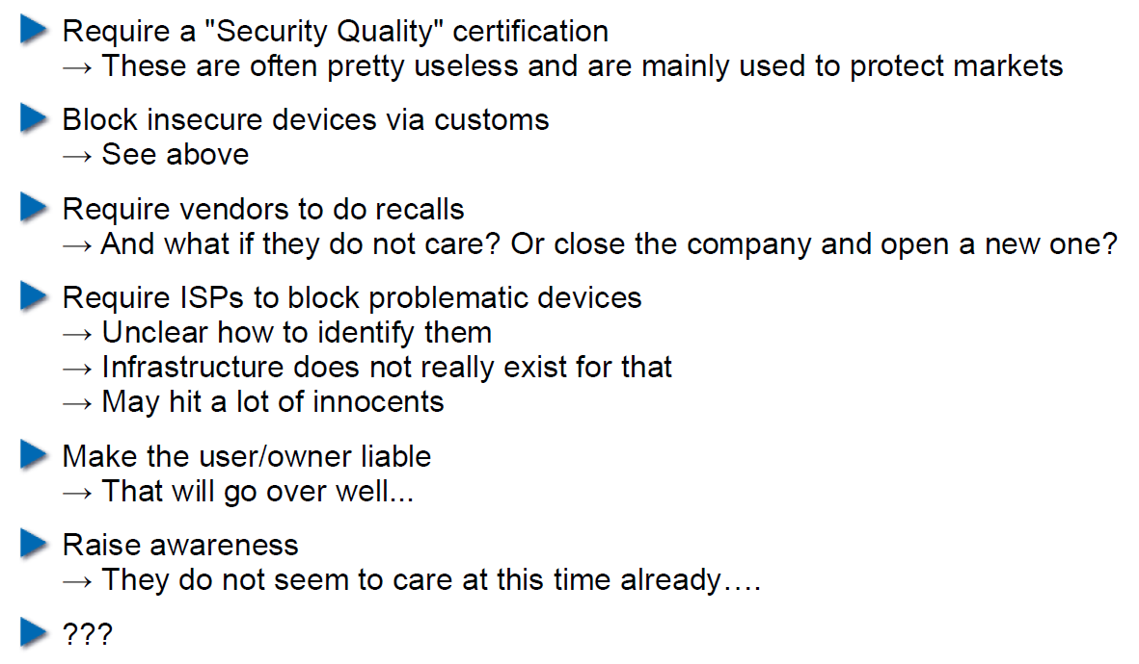

## Does it Pay to make Software Secure?

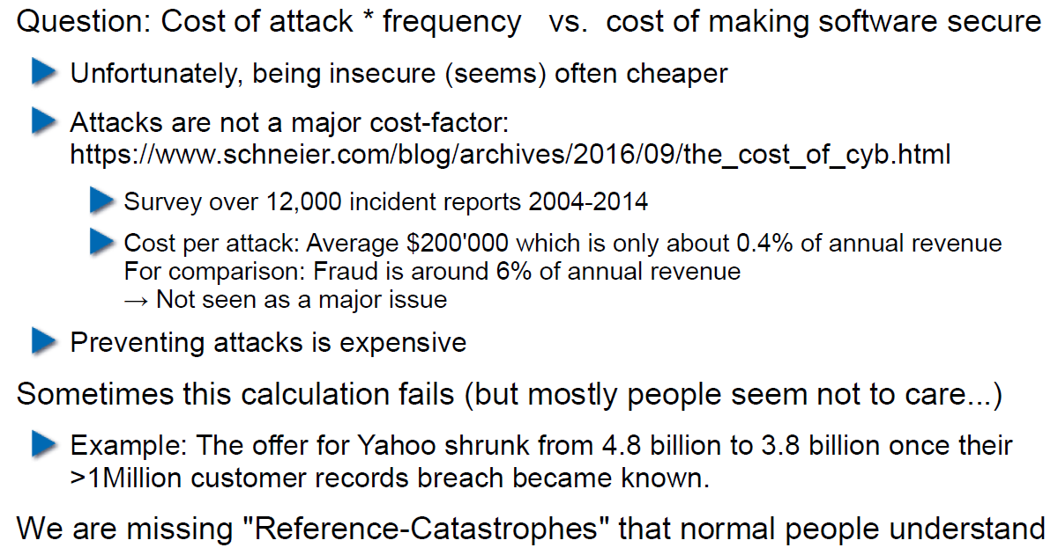

## So, what to do?

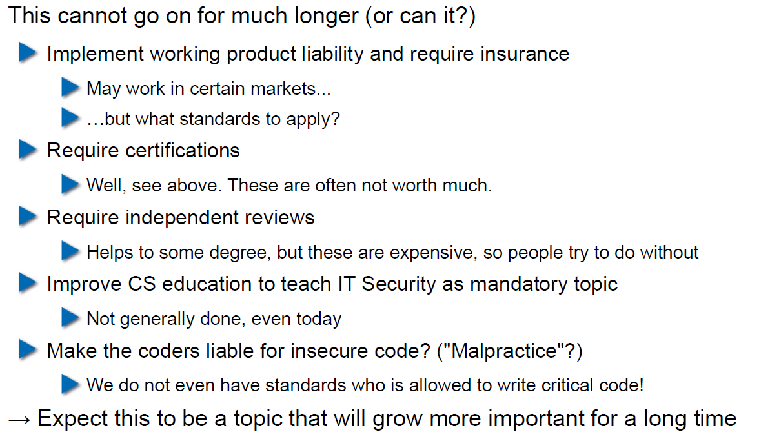

# Woche 5

## Agenda

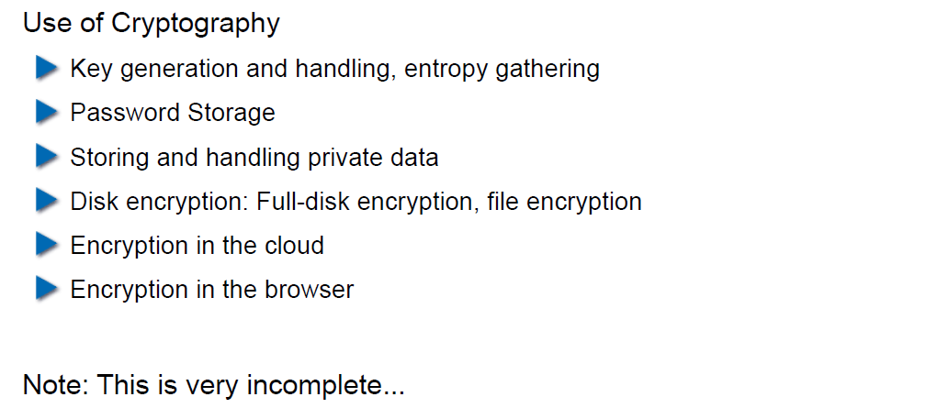

## Generating Cryptographic Keys

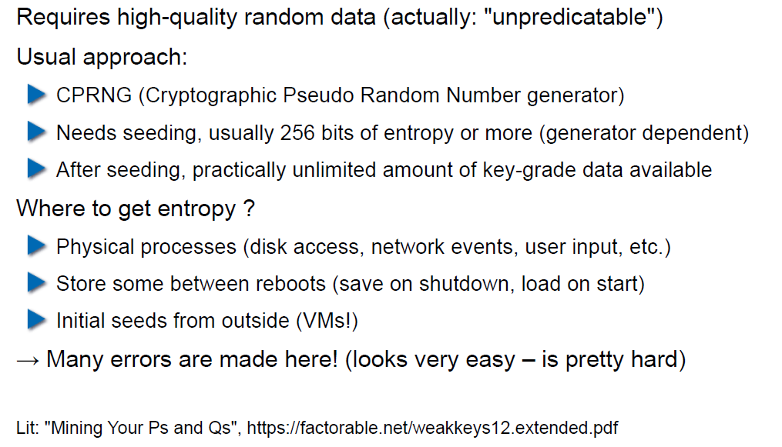

## Information-Theoretical Entropy

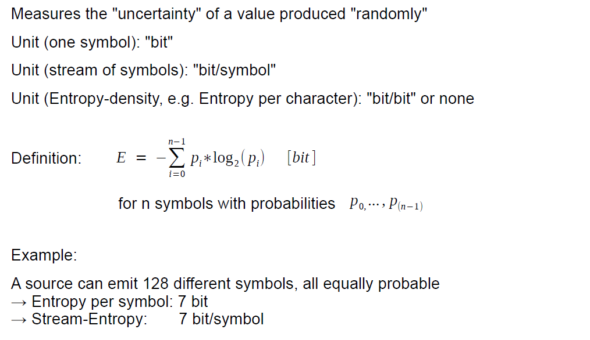

## Estimating Entropy is Tricky

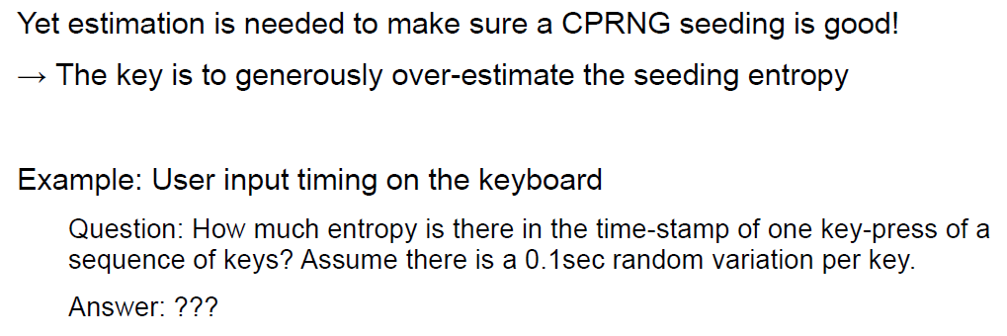

## Seeding a CPRNG

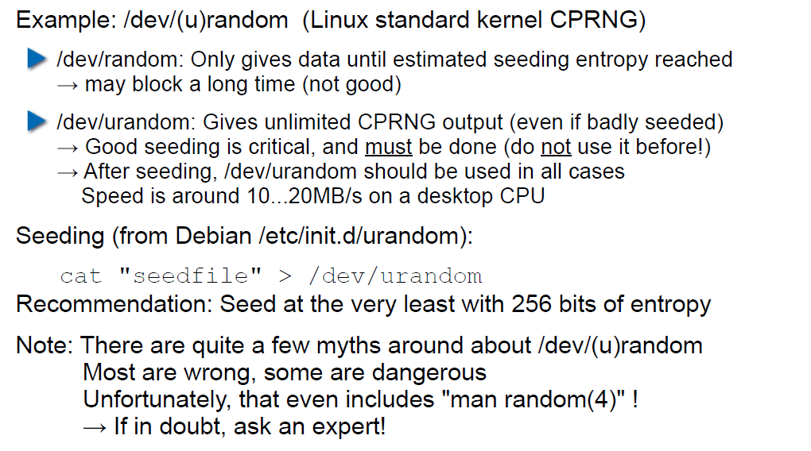

## Bad Seeding Examples

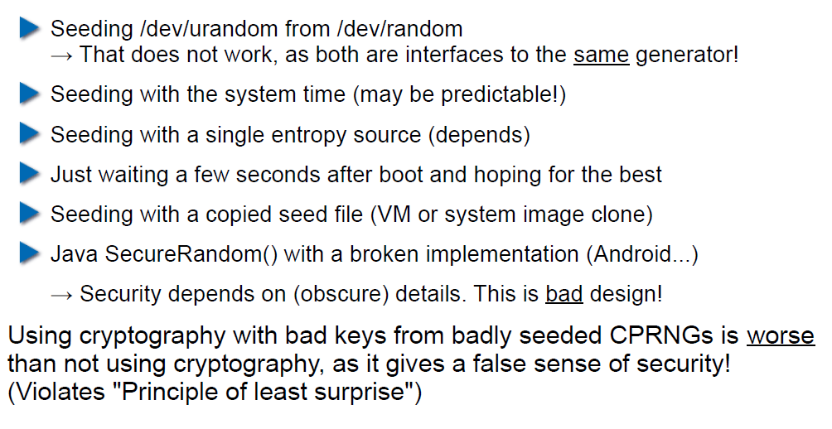

## Storing Cryptographic Keys Securely

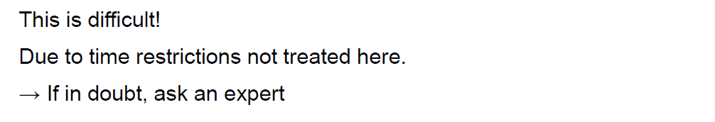

## Storing Passwords

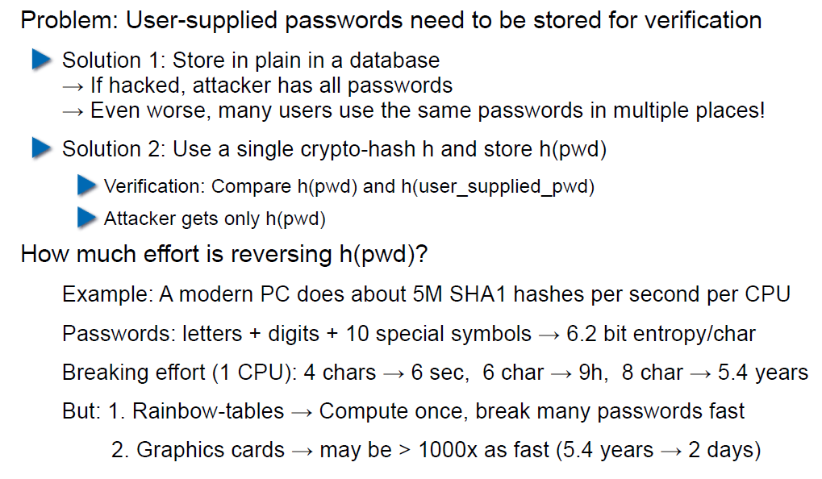

## Rainbow Table

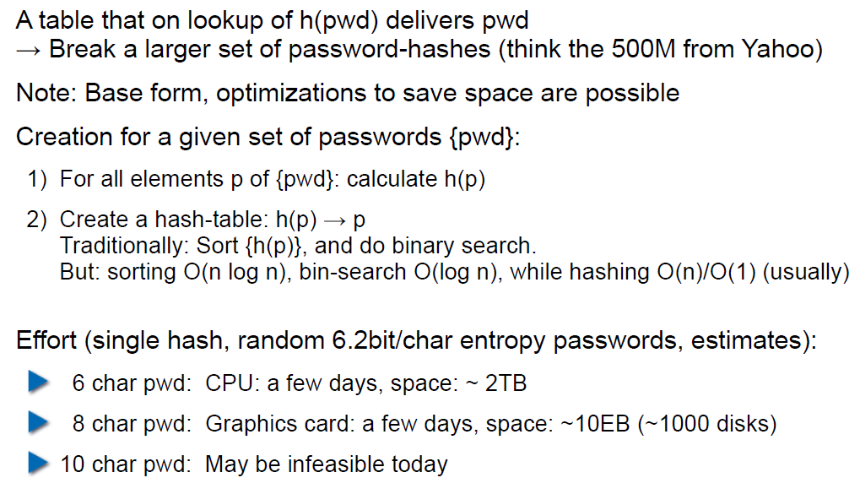

## Storing Passwords

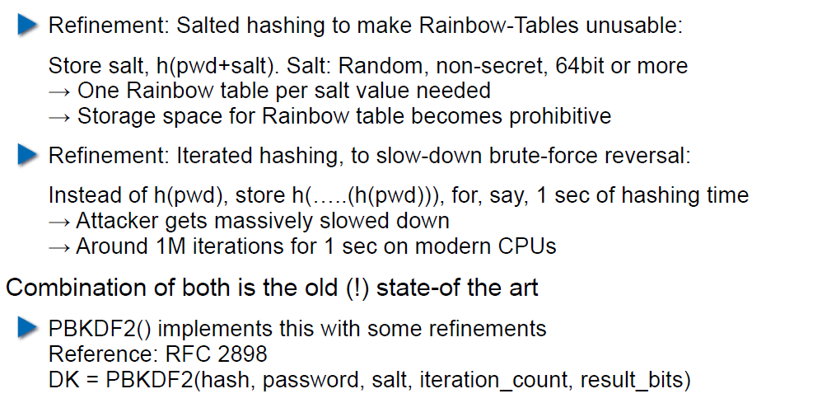

## So What is Wrong with PBKDF2?

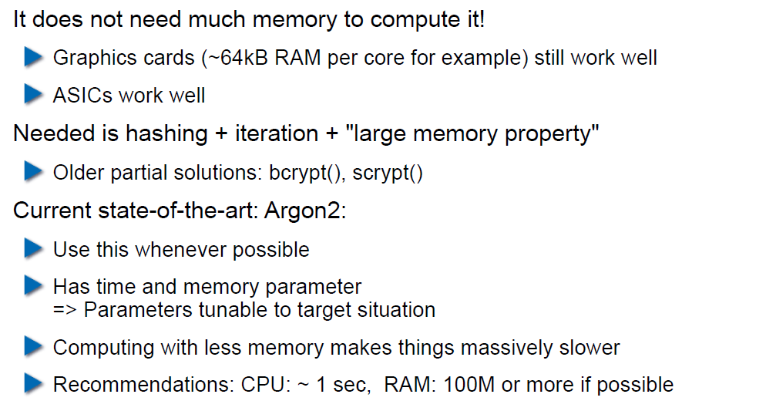

## Hardware RNGs

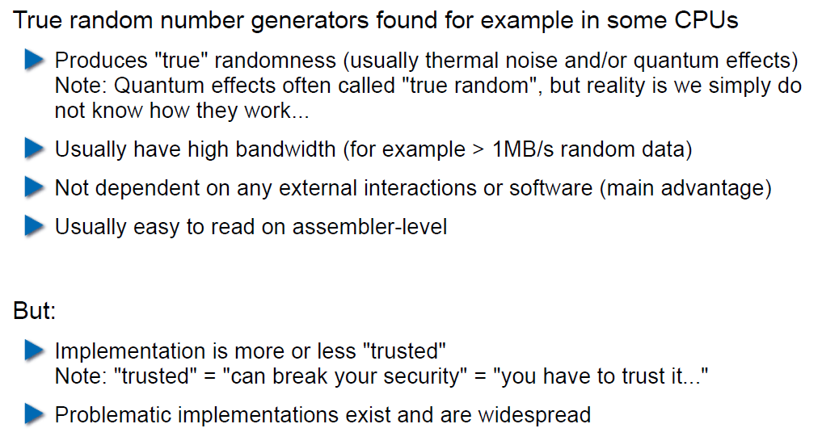

## Example 1: Via C3 Hardware CPRNG Schematic

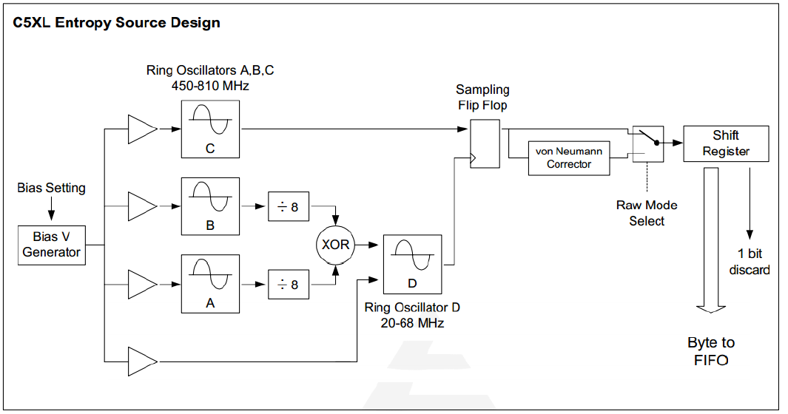

## Example 2: Intel RDRAND Schematic

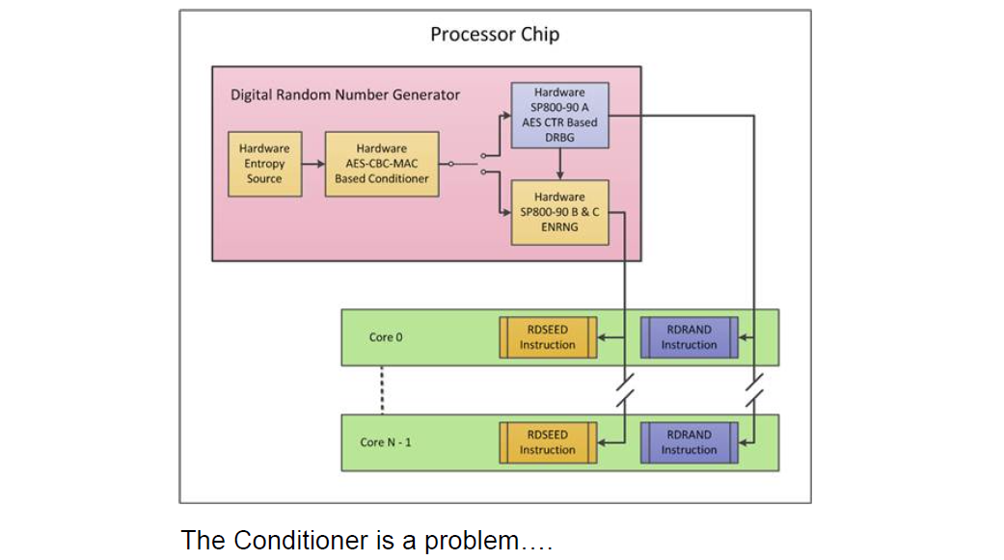

## Compromise on Design-Level

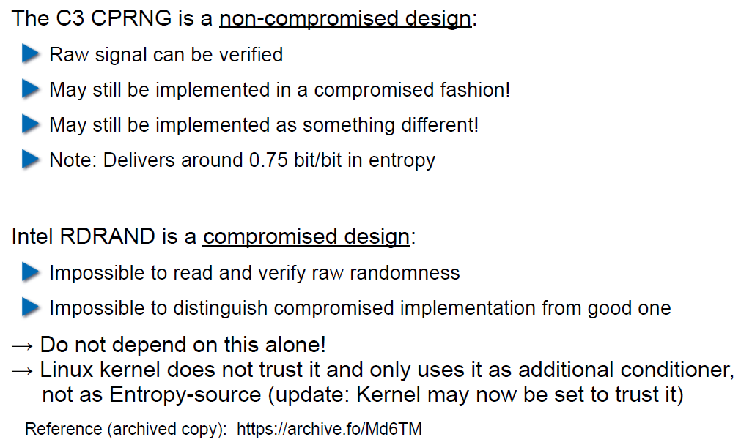

## Storing Private Data (as a Service Provider)

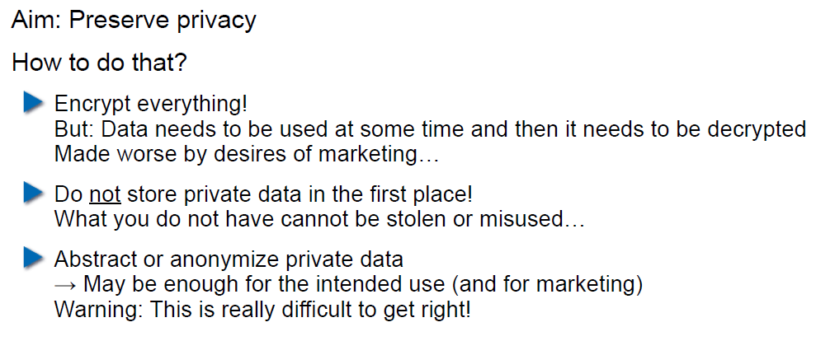

## Disk/Storage Encryption

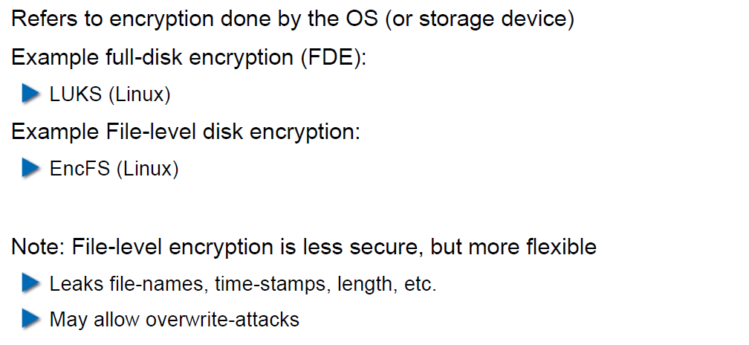

## Disk Encryption Protects Against What?

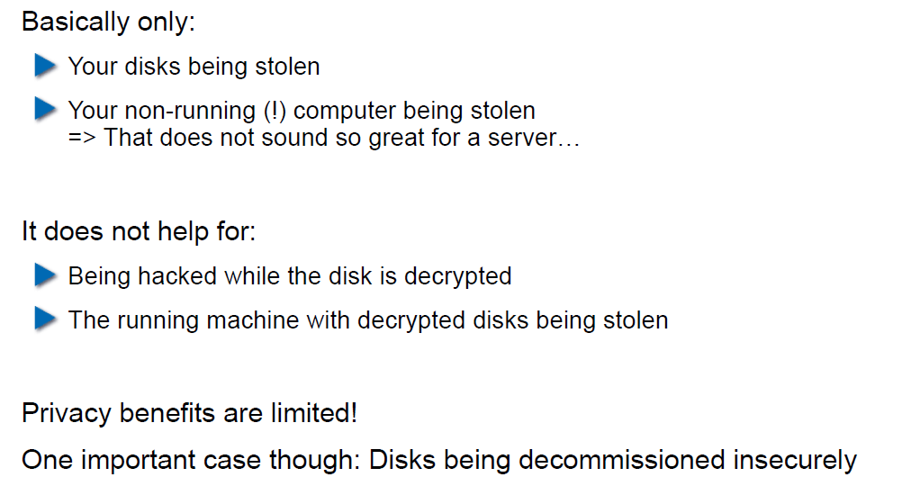

## Decryption Only With User Logged In

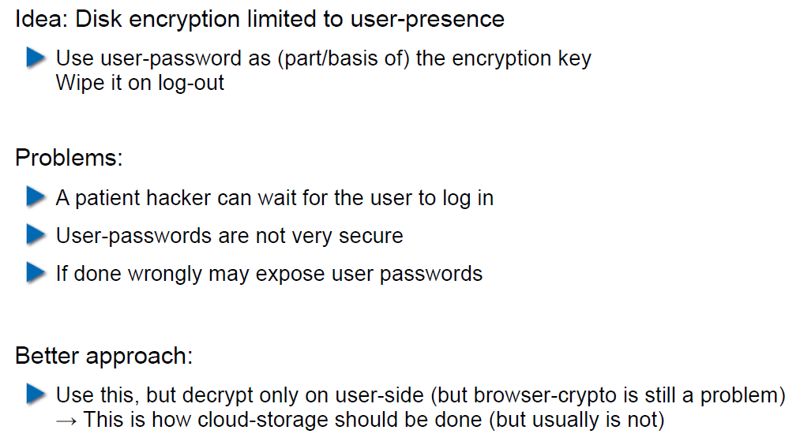

## Encryption in the Cloud

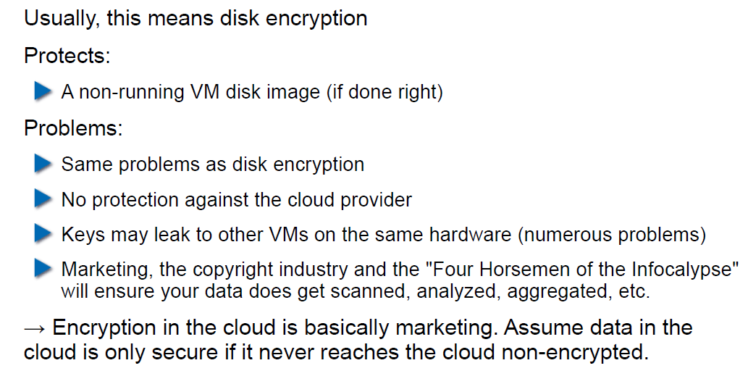

## JavaScript Client-Side Encryption in Web-Apps

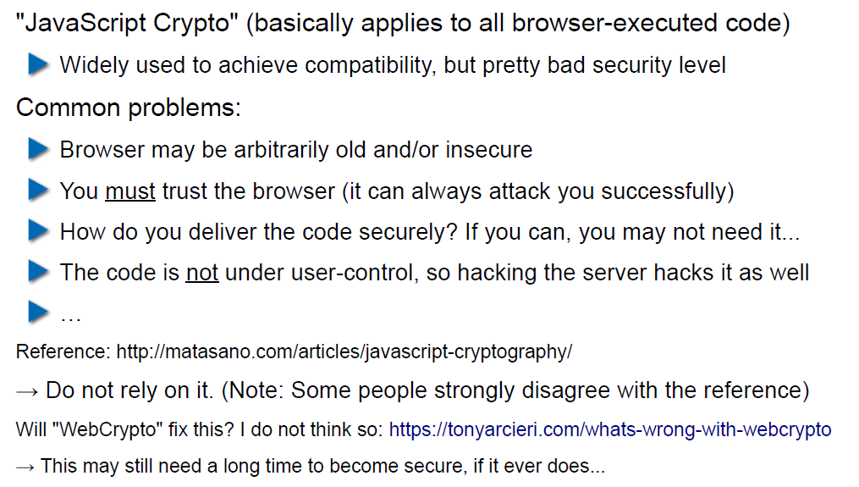

# Woche 6